UNITED STATES
SECURITIES AND EXCHANGE COMMISSION
Washington, D.C. 20549

SCHEDULE TO
(Rule 13e-4)
Tender Offer Statement Under Section 14(d)(1) or 13(e)(1)
of the Securities Exchange Act of 1934

BIODESIX, INC.
(Name of Subject Company (Issuer) and Filing Person (Offeror))
Options to Purchase Common Stock, Par Value $0.001 Per Share
(Title of Class of Securities)
09075X108
(CUSIP Number of Class of Securities)
Scott Hutton
President and Chief Executive Officer
Biodesix, Inc.
2970 Wilderness Place, Suite 100
Boulder, Colorado 80301
Telephone: (303) 417-0500
(Name, Address and Telephone Number of Person Authorized to Receive Notices and Communications on Behalf of Filing Person)
Copies to:
Frank F. Rahmani, Esq.
Samir A. Gandhi, Esq.
Sidley Austin LLP
555 California Street, Suite 2000
San Francisco, California 94104
Telephone: (415) 772-1200
Fax: (415) 772-7400

☐ | Check the box if the filing relates solely to preliminary communications made before the commencement of a tender offer.
Check the appropriate boxes below to designate any transactions to which the statement relates:

 | ☐ | third party tender offer subject to Rule 14d-1.
 | ☒ | Issuer tender offer subject to Rule 13e-4.
 | ☐ | going-private transaction subject to Rule 13e-3.
 | ☐ | amendment to Schedule 13D under Rule 13d-2.
Check the following box if the filing is a final amendment reporting the results of the tender offer: ☐
If applicable, check the appropriate box(es) below to designate the appropriate rule provision(s) relied upon:

 | ☐ | Rule 13e-4(i) (Cross-Border Issuer Tender Offer)
 | ☐ | Rule 14d-1(d) (Cross-Border Third-Party Tender Offer)

Item 1. Summary Term Sheet.
The information set forth under Summary Term SheetOverview and Summary Term SheetQuestions and Answers in the Offer to Exchange Eligible Options for New Options dated June 23, 2023 (the Exchange Offer), attached hereto as Exhibit (a)(1)(A), is incorporated herein by reference.
Item 2. Subject Company Information.

(a) | Name and Address.
Biodesix, Inc., a Delaware corporation (the Company), is the issuer of the securities subject to the Exchange Offer. The Companys principal executive offices are located at 2970 Wilderness Place, Suite 100, Boulder, Colorado 80301, and the telephone number of its principal executive offices is (303) 417-0500.

(b) | Securities.
This Tender Offer Statement on Schedule TO relates to an offer by the Company to certain employee optionholders, subject to specified conditions, to exchange some or all of their outstanding options to purchase shares of common stock, par value $0.001 per share (the Common Stock), for new options to purchase shares of the Companys Common Stock. Non-employee members of the Companys board of directors will not be eligible to participate in this offer.
An option will be eligible for exchange (an Eligible Option) if it was granted under the Companys 2020 Equity Incentive Plan and has an exercise price greater than $10.00 per share. As of June 16, 2023, Eligible Options to purchase 814,120 shares of Common Stock were outstanding.
Pursuant to the Exchange Offer, in exchange for the tender and cancellation of Eligible Options, the Company will grant new options (each, a New Option) following the Expiration Time (as defined in the Exchange Offer) for a reduced number of shares of Common Stock and subject to the terms and conditions described in the Exchange Offer and in the related accompanying Election Form, the form of which is attached hereto as Exhibit (a)(1)(C).
The information set forth in the Exchange Offer under Summary Term SheetOverview and Summary Term SheetQuestions and Answers and the information set forth under Section 1 (Eligible Holders; Eligible Options; the Proposed Exchange; Expiration and Extension of the Exchange Offer), Section 5 (Acceptance of Eligible Options for Exchange; Grant of New Options) and Section 7 (Price Range of Our Common Stock) of the Offering Memorandum for the Exchange Offer contained in the Exchange Offer (the Offering Memorandum) are incorporated herein by reference.

(c) | Trading Market and Price.
The information set forth under Section 7 (Price Range of Our Common Stock) of the Offering Memorandum is incorporated herein by reference.

2

Item 3. Identity and Background of Filing Person.

(a) | Name and Address.
The Company is both the filing person and the subject company. The information set forth under Item 2(a) above and under Section 9 (Interests of Directors and Executive Officers; Transactions and Arrangements Concerning Our Securities) of the Offering Memorandum are incorporated herein by reference.
The address of each executive officer and director of the Company is:
Biodesix, Inc.
2970 Wilderness Place, Suite 100
Boulder, Colorado 80301
The directors and executive officers of the Company are set forth below:

Executive Officers |  | Title
Scott Hutton |  | President, Chief Executive Officer and Director
Robin Harper Cowie |  | Chief Financial Officer
Ryan Siurek  Christopher Vazquez |  | Chief Accounting Officer  Chief Accounting Officer (effective July 3, 2023)
Directors
John Patience |  | Chairman of the Board
Jean Franchi |  | Director
Jon Faiz Kayyem, Ph.D. |  | Director
Lawrence T. Kennedy, Jr. |  | Director
Hany Massarany |  | Director
Jack Schuler |  | Director
Matthew Strobeck, Ph.D. |  | Director
Charles Watts, M.D. |  | Director
Item 4. Terms of the Transaction.

(a) | Material Terms.
The information set forth in the Exchange Offer under Summary Term SheetOverview and Summary Term SheetQuestions and Answers and the information set forth in the Offering Memorandum under Section 1 (Eligible Holders; Eligible Options; the Proposed Exchange; Expiration and Extension of the Exchange Offer), Section 3 (Procedures for Tendering Eligible Options), Section 4 (Withdrawal Rights), Section 5 (Acceptance of Eligible Options for Exchange; Grant of New Options), Section 6 (Conditions of the Exchange Offer), Section 8 (Information Concerning Biodesix; Financial Information), Section 10 (Accounting Consequences of the Exchange Offer), Section 11 (Legal Matters; Regulatory Approvals), Section 12 (Material United States Tax Consequences) and Section 13 (Extension of the Exchange Offer; Termination; Amendment) are incorporated herein by reference.

(b) | Purchases.
The information set forth under Section 9 (Interests of Directors and Executive Officers; Transactions and Arrangements Concerning Our Securities) of the Offering Memorandum is incorporated herein by reference.

3

Item 5. Past Contacts, Transactions, Negotiations and Agreements.

(a) | Agreements Involving the Subject Companys Securities.
The information set forth under Section 9 (Interests of Directors and Executive Officers; Transactions and Arrangements Concerning Our Securities) of the Offering Memorandum is incorporated herein by reference. The documents incorporated herein by reference as Exhibit (d)(1) also contain information regarding agreements relating to securities of the Company.
Item 6. Purposes of the Transaction and Plans or Proposals.

(a) | Purposes.
The information set forth under Section 2 (Purpose of the Exchange Offer; Additional Considerations) of the Offering Memorandum is incorporated herein by reference.

(b) | Use of Securities Acquired.
The information set forth under Section 5 (Acceptance of Eligible Options for Exchange; Grant of New Options) of the Offering Memorandum is incorporated herein by reference.

(c) | Plans.
The information set forth under Section 2 (Purpose of the Exchange Offer; Additional Considerations) of the Offering Memorandum is incorporated herein by reference.
Item 7. Source and Amount of Funds or Other Consideration.

(a) | Source of Funds.
The information set forth under Section 14 (Consideration; Fees and Expenses) of the Offering Memorandum is incorporated herein by reference.

(b) | Conditions.
The information set forth under Section 6 (Conditions of the Exchange Offer) of the Offering Memorandum is incorporated herein by reference.

(c) | Borrowed Funds.
Not applicable.
Item 8. Interest in Securities of the Subject Company.

(a) | Securities Ownership.
The information set forth under Section 9 (Interests of Directors and Executive Officers; Transactions and Arrangements Concerning Our Securities) of the Offering Memorandum is incorporated herein by reference.

(b) | Securities Transactions.
The information set forth under Section 9 (Interests of Directors and Executive Officers; Transactions and Arrangements Concerning Our Securities) of the Offering Memorandum is incorporated herein by reference.

4

Item 9. Persons/Assets, Retained, Employed, Compensated or Used.

(a) | Solicitations or recommendations.
Not applicable.
Item 10. Financial Statements.

(a) | Financial Information.
The information set forth under Section 8 (Information Concerning Biodesix; Financial Information), including Schedule A, and Section 15 (Additional Information) of the Offering Memorandum is incorporated herein by reference.

(b) | Pro Forma Information.
Not applicable.
Item 11. Additional Information.

(a) | Agreements, Regulatory Requirements and Legal Proceedings.

 | (1) | The information set forth under Section 9 (Interests of Directors and Executive Officers; Transactions and Arrangements Concerning Our Securities) of the Offering Memorandum is incorporated herein by reference.

 | (2) | The information set forth under Section 11 (Legal Matters; Regulatory Approvals) of the Offering Memorandum is incorporated herein by reference.

 | (3) | Not applicable.

 | (4) | Not applicable.

 | (5) | Not applicable.

(b) | Other Material Information.
Not applicable.
Item 12. Exhibits.

Exhibit  Number |  | Description
(a)(1)(A) |  | Offer to Exchange Eligible Options for New Options, dated June 23, 2023
(a)(1)(B) |  | Form of Announcement Email to Eligible Holders
(a)(1)(C) |  | Election Form
(a)(1)(D) |  | Notice of Withdrawal of Election Form
(a)(1)(E) |  | Form of Email Confirming Receipt of Election Form
(a)(1)(F) |  | Form of Email Confirming Receipt of Notice of Withdrawal of Election Form
(a)(1)(G) |  | Form of Reminder Email to Eligible Holders Regarding the Expiration of the Exchange Offer
(a)(1)(H) |  | Form of Email to Eligible Holders Confirming Acceptance of Eligible Options
(a)(1)(I) |  | Form of Email Notice Regarding Rejection of Options for Exchange
(a)(1)(J) |  | Form of Expiration Notice Email
(a)(1)(K) |  | Forms of Stock Option Grant Notice, Option Agreement and Notice of Exercise under the 2020 Equity Incentive Plan (incorporated by reference to Exhibit 10.5.1 to the Registrants Annual Report on Form 10-K filed with the SEC on March 16, 2021).
(a)(1)(L) |  | Stock Option Exchange Program Presentation
(b) |  | Not applicable

5

(d)(1) |  | Biodesix, Inc. 2020 Equity Incentive Plan (incorporated by reference to Exhibit 10.5 to the Registrants Registration Statement on Form S-1/A (No. 333-249260), filed with the Commission on October 26, 2020).
(g) |  | Not applicable
(h) |  | Not applicable
107 |  | Filing Fee Table
Item 13. Information Required by Schedule 13E-3.
Not applicable.
SIGNATURES
After due inquiry and to the best of my knowledge and belief, I certify that the information set forth in this statement is true, complete, and correct.

 |  | BIODESIX, INC.
By: |  | /s/ Scott Hutton
 |  | Scott Hutton
 |  | President and Chief Executive Officer
Dated: June 23, 2023

6
Exhibit (a)(1)(A)
BIODESIX, INC.
2970 Wilderness Place, Suite 100
Boulder, Colorado 80301
OFFER TO EXCHANGE ELIGIBLE OPTIONS FOR NEW OPTIONS
JUNE 23, 2023
BIODESIX, INC.
SUMMARY TERM SHEETOVERVIEW
OFFER TO EXCHANGE ELIGIBLE OPTIONS FOR NEW OPTIONS
This offer and withdrawal rights will expire at 10:00 p.m., Mountain Time,
on July 24, 2023, unless extended
By this Offer to Exchange Eligible Options for New Options (as the context requires, this document and the actions taken hereby, the Exchange Offer), Biodesix, Inc., which we refer to in this document as we, us, our or Biodesix, is giving each Eligible Holder (as defined below) the opportunity to exchange one or more Eligible Options (as defined below) for New Options (as defined below), as discussed below and in the Offering Memorandum for the Exchange Offer beginning on page 13 (the Offering Memorandum).
The Expiration Time of the Exchange Offer is 10:00 p.m., Mountain Time, on July 24, 2023. If we extend the period of time during which this Exchange Offer remains open, the term Expiration Time will refer to the last time and date on which this Exchange Offer expires.
You are an Eligible Holder if:

 |  |  | on the New Option Grant Date (as defined below), you are employed by Biodesix; and

 |  |  | you are not a non-employee member of Biodesixs board of directors.
An Eligible Option is an outstanding option that:

 |  |  | is held by an Eligible Holder;

 |  |  | has an exercise price greater than $10.00 per share; and

 |  |  | was granted under our 2020 Equity Incentive Plan (the 2020 Incentive Plan).
If you choose to participate in the Exchange Offer and tender Eligible Options for exchange, and if we accept your tendered Eligible Options, then we will grant you an award of stock options (each, a New Option) with the following terms (collectively, the New Option Terms):

 |  |  | Each New Option will have an exercise price equal to the closing price of our common stock reported on The Nasdaq Global Select Market (Nasdaq) on the New Option Grant Date.

 |  |  | Each New Option will represent your right to purchase a number of shares of our common stock that is calculated using an exchange ratio based on the exercise price of your tendered Eligible Option. The chart below sets forth the applicable exchange ratios for outstanding Eligible Options based on the dollar range of the exercise prices of such Eligible Options.

1

Eligible Option Exercise Price Range |  | Exchange Ratio  (Surrendered Eligible  Options: New Options)*
$10.01 to $14.00 |  | 3.2 to 1
$14.01 to $18.00 |  | 3.5 to 1
$18.01 to $20.00 |  | 4.3 to 1
$20.01 and above |  | 4.9 to 1

* | Rounded up to the nearest share

 |  |  | Your New Options will be granted under our 2020 Incentive Plan.

 |  |  | Each New Option will be granted as a nonqualified stock option (NSO).

 |  |  | Each New Option will have a maximum term of ten (10) years.

 |  |  | To the extent any Eligible Option that you tender for exchange is partially vested as of the Expiration Time, you will receive one New Option in exchange for the vested shares underlying such Eligible Option and one New Option in exchange for the unvested shares underlying such Eligible Option.

 |  |  | New Options will not be vested on the New Option Grant Date. The vesting terms of your New Options will be as follows:

 |  |  | Each New Option granted in exchange for the vested shares underlying an Eligible Option will fully vest on the first day of the month following the first anniversary of the month in which the Exchange Offer is completed. For illustration, if the Exchange Offer is completed on July 24, 2023, each New Option granted in exchange for the vested shares underlying an Eligible Option will fully vest on August 1, 2024.

 |  |  | Each New Option granted in exchange for the unvested shares underlying an Eligible Option will vest under an extended vesting schedule, with vesting commencing on the first day of the month following the first anniversary of the month in which the Exchange Offer is completed, and occurring in a series of equal monthly installments over the number of months that were remaining in the surrendered Eligible Options vesting schedule immediately prior to the Exchange Offer. For illustration, if the Exchange Offer is completed on July 24, 2023, and an Eligible Option that has 6 months of vesting remaining is exchanged for a New Option, the vesting schedule of the New Option will provide for vesting in equal installments on a monthly basis for 6 months beginning on August 1, 2024.

 |  |  | As with any unvested equity award under our 2020 Incentive Plan, you must remain in continuous service with Biodesix through each vesting date.
The commencement date of the Exchange Offer is June 23, 2023. We are making the Exchange Offer upon the terms and subject to the conditions described in the Offering Memorandum and in the related Election Form distributed with the Offering Memorandum. The Exchange Offer is voluntary with respect to each Eligible Option you hold. You are not required to participate in the Exchange Offer. If you hold more than one option grant that qualifies as an Eligible Option and elect to participate in the Exchange Offer, you will be allowed to tender for exchange as few or as many of your Eligible Option grants as you wish. Eligible Options properly tendered in this Exchange Offer and accepted by us for exchange will be cancelled, and your New Options will be granted with the New Option Terms effective promptly following the Expiration Time (such date, the New Option Grant Date).
See the Risk Factors section of this Exchange Offer beginning on page 12 for a discussion of risks and uncertainties that you should consider before agreeing to exchange your Eligible Options for New Options. You should consider, among other things, these risks and uncertainties before deciding whether to participate in the Exchange Offer.

2

Shares of our common stock are quoted on Nasdaq under the symbol BDSX. On June 16, 2023, the closing price of our common stock as reported on Nasdaq was $1.54 per share. We recommend that you obtain current market quotations for our common stock before deciding whether to elect to participate in the Exchange Offer.
You should direct any questions about the Exchange Offer or requests for assistance (including requests for additional or paper copies of the Offering Memorandum, the Election Form, the Notice of Withdrawal or any other documents relating to the Exchange Offer) by email to equityadmin@biodesix.com.
IMPORTANT
If you choose to participate in the Exchange Offer, you must properly complete and sign the accompanying Election Form and deliver the properly completed and signed Election Form to us so that we receive it before 10:00 p.m. Mountain Time, on July 24, 2023 (or such later date as may apply if the Exchange Offer is extended), by the Election Form sent via AdobeSign.
You are responsible for making sure that the Election Form is delivered as indicated above. You must allow for sufficient time to complete, sign and deliver your Election Form to ensure that we receive your Election Form before the Expiration Time.
You do not need to return your stock option agreements for your Eligible Options to be cancelled and exchanged in the Exchange Offer. We will provide you with a written confirmation of the cancellation of any such options along with a stock option agreement for your New Options shortly following the grant of your New Options.
Although the Board has approved the Exchange Offer, consummation of the Exchange Offer is subject to the satisfaction or waiver of the conditions described in Section 6 of the Offering Memorandum (Conditions of the Exchange Offer). Neither we nor the Board (or the compensation committee thereof) makes any recommendation as to whether you should participate, or refrain from participating, in the Exchange Offer. You must make your own decision whether to participate. You should consult your personal financial and tax advisors if you have questions about your financial or tax situation as it relates to the Exchange Offer.
Neither the Securities and Exchange Commission nor any state securities commission has approved or disapproved of this transaction or passed upon the fairness or merits of this transaction or the accuracy or adequacy of the information contained in the Exchange Offer. Any representation to the contrary is a criminal offense.
WE HAVE NOT AUTHORIZED ANY PERSON TO MAKE ANY RECOMMENDATION ON OUR BEHALF AS TO WHETHER OR NOT YOU SHOULD PARTICIPATE IN THE EXCHANGE OFFER. YOU SHOULD RELY ONLY ON THE INFORMATION CONTAINED IN THIS DOCUMENT OR IN DOCUMENTS TO WHICH WE HAVE REFERRED YOU.
WE HAVE NOT AUTHORIZED ANYONE TO GIVE YOU ANY INFORMATION OR TO MAKE ANY REPRESENTATION IN CONNECTION WITH THE EXCHANGE OFFER OTHER THAN THE INFORMATION AND REPRESENTATIONS CONTAINED IN THIS DOCUMENT OR IN THE RELATED ELECTION FORMS. IF ANYONE MAKES ANY RECOMMENDATION OR REPRESENTATION TO YOU OR GIVES YOU ANY INFORMATION, YOU SHOULD NOT RELY UPON THAT RECOMMENDATION, REPRESENTATION OR INFORMATION AS HAVING BEEN AUTHORIZED BY BIODESIX.

3

SUMMARY TERM SHEETQUESTIONS AND ANSWERS
OFFER TO EXCHANGE ELIGIBLE OPTIONS FOR NEW OPTIONS
Set forth below are answers to some of the questions that you may have about the Exchange Offer. We encourage you to carefully read the remainder of this Offer to Exchange Eligible Options for New Options and the accompanying Election Form. Where appropriate, we have included references to the relevant sections of the Offering Memorandum where you can find a more complete description of the topics in this summary.

No. Question |  | Page
Q1. Why is Biodesix making the Exchange Offer? |  | 5
Q2. Who is eligible to participate in the Exchange Offer? |  | 5
Q3. Which options are subject to the Exchange Offer? |  | 5
Q4. Will the terms and conditions of my New Options be the same as my exchanged options? |  | 6
Q5. How many New Options will I receive for the Eligible Options I exchange? |  | 6
Q6. Will my New Options have an exercise or purchase price? |  | 6
Q7. When will my New Options vest? |  | 6
Q8. Do I need to exercise my New Option in order to receive shares? |  | 7
Q9. If I participate in the Exchange Offer, when will my New Options be granted? |  | 7
Q10.What happens to my New Options if I terminate my employment with Biodesix? |  | 7
Q11.Must I participate in the Exchange Offer? |  | 8
Q12.How should I decide whether or not to participate in the Exchange Offer? |  | 8
Q13.How do I find out how many Eligible Options I have and what their exercise prices are? |  | 8
Q14.Can I tender for exchange stock options that I have already fully exercised? |  | 8
Q15.Can I tender for exchange the remaining unexercised portion of an Eligible Option that I have already partially exercised? |  | 9
Q16.Can I tender for exchange a portion of an Eligible Option? |  | 9
Q17.What if I am on an authorized leave of absence during the Exchange Offer? |  | 9
Q18.What happens if my employment with Biodesix terminates before the Expiration Time? |  | 9
Q19.Will I owe taxes if I participate in the Exchange Offer? |  | 9
Q20.Will I owe taxes if I do not participate in the Exchange Offer? |  | 10
Q21.What will happen to my Eligible Options if I participate in the Exchange Offer? |  | 10
Q22.Is it possible for my New Options to be or become underwater? |  | 10
Q23.What happens to Eligible Options that I choose not to tender or that are not accepted for exchange in the Exchange Offer? |  | 10
Q24.How long do I have to decide whether to participate in the Exchange Offer? |  | 10
Q25.How do I tender my Eligible Options for exchange? |  | 10
Q26.Can I withdraw previously tendered Eligible Options? |  | 11
Q27.How will I know whether you have received my Election Form or my Notice of Withdrawal? |  | 11
Q28.What will happen if I do not return my Election Form by the deadline? |  | 11
Q29.What if I have any questions regarding the Exchange Offer? |  | 12

4

Q1. Why is Biodesix making the Exchange Offer?
We have been thoughtfully considering the idea of an Exchange Offer since 2022. In early 2022, we began internal discussions to consider various ways to better incentivize and retain employees to continue our growth-oriented goals and objectives.
We face significant competition for experience and talented personnel in our industry, and stock options are an important part of the incentive compensation offered to our employees. The price of our common stock has decreased significantly since March 1, 2021. While we have made significant progress in our core lung diagnostic business, including continued sales growth and payor reimbursement for clinical diagnostics testing, the price of our common stock remains relatively low. On June 16, 2023, the closing price of our common stock on Nasdaq was $1.54 per share, resulting in approximately 76% of our outstanding stock options held by eligible employees being underwater (option exercise price in excess of closing stock price), and for a large number of our employees, significantly so. As a result, we may face a considerable challenge in retaining our employees, and there is a possibility that our competitors may be able to offer equity incentives that are more attractive and that, in some cases, could make the terms of employment at a new employer more attractive than what we are able to offer to our existing employees.
We believe the Exchange Offer would restore equity value, increase retention and motivation, provide non-cash compensation incentives and better align our employee and stockholder interests for long-term growth. Underwater stock option awards are of limited benefit in motivating and retaining our employees. Through the Exchange Offer, we believe that we will be able to enhance long-term stockholder value by increasing our ability to retain experienced and talented employees and by better aligning the interests of these employees with the interests of our stockholders.
The Exchange Offer is designed to address these concerns as well as improve morale among our employees. Our compensatory stock options cannot be sold. They can either be voluntarily exercised or they will expire unexercised. Underwater stock options are viewed by us as less effective performance incentives because they provide less or no perceived value to employee option holders. Because many of our options are significantly underwater, we believe the likelihood that there will be a positive spread between their exercise prices and the near-term price of our common stock is too low to provide meaningful incentive to employee option holders.
See Section 2 of the Offering Memorandum (Purpose of The Exchange Offer; Additional Considerations) for more information.
Q2. Who is eligible to participate in the Exchange Offer?
Only Eligible Holders are eligible to participate in the Exchange Offer. You are an Eligible Holder if:

 |  |  | on the New Option Grant Date you are employed by Biodesix; and

 |  |  | you are not a non-employee member of our Board.
See Section 1 of the Offering Memorandum (Eligible Holders; Eligible Options; the Proposed Exchange; Expiration and Extension of the Exchange Offer) for more information.
Q3. Which options are subject to the Exchange Offer?
Under the Exchange Offer, Eligible Holders will be able to elect to tender outstanding Eligible Options for exchange.
An Eligible Option is an outstanding option that:

 |  |  | is held by an Eligible Holder;

5

 |  |  | has an exercise price greater than $10.00 per share; and

 |  |  | was granted under our 2020 Incentive Plan.
See Section 1 of the Offering Memorandum (Eligible Holders; Eligible Options; the Proposed Exchange; Expiration and Extension of the Exchange Offer) for more information.
Q4. Will the terms and conditions of my New Options be the same as my exchanged options?
No. The terms and conditions of your New Options, including the exercise price, vesting schedule, and term of your New Options, will be different than your tendered Eligible Options.
Q5. How many New Options will I receive for the Eligible Options I exchange?
The number of shares to be granted to you under each New Option will be determined using an exchange ratio that takes into account the exercise price of your tendered Eligible Option. The chart below sets forth the applicable exchange ratio for outstanding Eligible Options based on the dollar range of the exercise prices of such Eligible Options.

Eligible Option Exercise Price Range |  | Exchange Ratio  (Surrendered Eligible  Options: New Options)*
$10.01 to $14.00 |  | 3.2 to 1
$14.01 to $18.00 |  | 3.5 to 1
$18.01 to $20.00 |  | 4.3 to 1
$20.01 and above |  | 4.9 to 1

* | Rounded up to the nearest share
For example, if you hold an Eligible Option to purchase 100 shares at an exercise price of $20.67 per share, you will receive a New Option to purchase 21 shares at an exercise price equal to the closing price of a share of common stock on the New Option Grant Date. To the extent any Eligible Option that you tender for exchange is partially vested as of the Expiration Time, you will receive one New Option in exchange for the vested shares underlying such Eligible Option and one New Option in exchange for the unvested shares underlying such Eligible Option.
Q6. Will my New Options have an exercise or purchase price?
Your New Options will have an exercise price equal to the closing price of our common stock as reported on Nasdaq on the date that we grant your New Options, i.e., the New Option Grant Date, which is currently expected to be July 24, 2023. Each New Option will represent your right to purchase a number of shares of our common stock that was calculated based on the applicable exchange ratio set forth above.
See Section 1 of the Offering Memorandum (Eligible Holders; Eligible Options; the Proposed Exchange; Expiration and Extension of the Exchange Offer) for more information and Section 7 of the Offering Memorandum (Price Range of Our Common Stock) for information concerning the historical prices of our common stock.
Q7. When will my New Options vest?
Each New Option will be unvested on the date of grant.
Each New Option granted in exchange for the vested shares underlying an Eligible Option will fully vest on the first day of the month following the first anniversary of the month in which the Exchange Offer is completed. For illustration, if the Exchange Offer is completed on July 24, 2023, each New Option granted in exchange for the vested shares underlying an Eligible Option will fully vest on August 1, 2024.

6

Each New Option granted in exchange for the unvested shares underlying an Eligible Option will vest under an extended vesting schedule, with vesting commencing on the first day of the month following the first anniversary of the month in which the Exchange Offer is completed, and occurring in a series of equal monthly installments over the number of months that were remaining in the surrendered Eligible Options vesting schedule immediately prior to the Exchange Offer. For illustration, if the Exchange Offer is completed on July 24, 2023, and an Eligible Option that has 6 months of vesting remaining is exchanged for a New Option, the vesting schedule of the New Option will provide for vesting in equal installments on a monthly basis for 6 months beginning on August 1, 2024.
As with any unvested equity award under our 2020 Incentive Plan, you must remain in continuous service with Biodesix through each vesting date.
Q8. Do I need to exercise my New Option in order to receive shares?
Yes. You will need to exercise the vested portion of your New Option and pay the purchase price to receive shares of common stock.
Q9. If I participate in the Exchange Offer, when will my New Options be granted?
Unless we amend or terminate the Exchange Offer in accordance with its terms, we will grant you New Options in exchange for Eligible Options with respect to which you properly made a valid election (and did not validly revoke that election), effective as of the New Option Grant Date, which is currently expected to be July 24, 2023. The New Options will reflect the New Option Terms.
See Section 1 of the Offering Memorandum (Eligible Holders; Eligible Options; the Proposed Exchange; Expiration and Extension of the Exchange Offer) for more information.
Q10. What happens to my New Options if I terminate my employment with Biodesix?
Vesting of your New Options will cease upon termination of your service with Biodesix. Your unvested New Options will be forfeited to us.
In general, pursuant to the 2020 Incentive Plan, the vested portion of your New Options may be exercised until three months following termination of your service with Biodesix unless (i) your employment is terminated by reason of your death or you die within three months following your termination for any reason other than for cause, in which case the New Option may be exercised (to the extent vested on the effective date of such termination of employment) until and including the earlier to occur of (A) 18 months after the date of such termination and (B) the expiration date of the New Option, (ii) your employment is terminated by reason of your disability, in which case the New Option may be exercised (to the extent vested on the effective date of such termination of employment) until and including the earlier to occur of (A) 12 months after the date of such termination and (B) the expiration date of the New Option, or (iii) you are terminated for cause, in which case the New Option will cease to be exercisable immediately upon your termination.
Nothing in the Exchange Offer should be construed to confer upon you the right to remain employed by Biodesix. The terms of your employment with Biodesix remain unchanged. We cannot guarantee or provide you with any assurance that you will not be subject to involuntary termination or that you will otherwise remain employed by Biodesix until the expiration of the Exchange Offer, the New Option Grant Date or thereafter during the vesting period of the New Options. In addition, we cannot provide any assurance that your employment with Biodesix will continue past the vesting date of any New Option issued in exchange for an Eligible Option that would have been vested and exercisable as of your termination date had the Eligible Option not been exchanged for a New Option.
See Section 1 of the Offering Memorandum (Eligible Holders; Eligible Options; the Proposed Exchange; Expiration and Extension of the Exchange Offer) and Section 5 of the Offering Memorandum (Acceptance of Eligible Options for Exchange; Grant of New Options) for more information.

7

Q11. Must I participate in the Exchange Offer?
No. Participation in the Exchange Offer is voluntary and no response to the Exchange Offer is required. If you do not respond to the Exchange Offer by the Expiration Time, you will not be eligible to participate in the Exchange Offer and your Eligible Options will remain outstanding and subject to their current terms. If you hold more than one option grant under our 2020 Incentive Plan that qualifies as an Eligible Option and would like to participate in the Exchange Offer, you will be allowed to elect to tender for exchange as few or as many of your Eligible Option grants as you wish. If you choose not to participate in the Exchange Offer, then your Eligible Options will remain outstanding and subject to their current terms.
Q12. How should I decide whether or not to participate in the Exchange Offer?
We are providing substantial information to assist you in making your own informed decision. Please read all the information contained in the various sections of the Offering Memorandum below, including the information in Section 2 (Purpose of The Exchange Offer; Additional Considerations), Section 7 (Price Range of Our Common Stock), Section 8 (Information Concerning Biodesix; Financial Information), Section 9 (Interests of Directors and Executive Officers; Transactions and Arrangements Concerning Our Securities), Section 12 (Material United States Tax Consequences) and Section 15 (Additional Information) of the Offering Memorandum. You should seek further advice from your legal counsel, accountant and financial advisor. Participation in the Exchange Offer is entirely your decision and should be made based on your personal circumstances. No one from Biodesix is, or will be, authorized to provide you with legal, tax, financial or other advice or recommendations regarding whether you should participate in the Exchange Offer.
In addition to reviewing the materials provided, please note the following:

 |  |  | The Exchange Offer is not a one-for-one exchange. Any New Options you receive will be exercisable for fewer shares than your Eligible Options, based on the applicable exchange ratio.

 |  |  | Options provide value upon exercise only if the price of our common stock increases after the grant date. Also, because the exchange ratios for the option exchange are not one-for-one, it is possible that, at some point in the future, Eligible Options you choose to exchange could be economically more valuable than the New Options you receive pursuant to the Exchange Offer.

 |  |  | New Options granted in the Exchange Offer will be subject to new, longer vesting schedules, even if the Eligible Options you exchange are fully vested at the time of the exchange.

 |  |  | New Options granted in the Exchange Offer will have a maximum term of ten (10) years.

 |  |  | You should carefully consider the potential tax consequences of your exchange of Eligible Options for New Options.
Please also review the Risk Factors that appear on page 12.
Q13. How do I find out how many Eligible Options I have and what their exercise prices are?
The Election Form distributed along with the Exchange Offer includes a list of your Eligible Options as of June 16, 2023. At any time during the Exchange Offer, you may review your grants in Shareworks or contact us via email at equityadmin@biodesix.com to confirm the number of option grants that you have and the grant dates, remaining term, exercise prices, vesting schedule and other information regarding such option grants.
Q14. Can I tender for exchange stock options that I have already fully exercised?
No. The Exchange Offer applies only to outstanding Eligible Options. An option that has been fully exercised is no longer outstanding and is therefore not an Eligible Option.

8

Q15. Can I tender for exchange the remaining unexercised portion of an Eligible Option that I have already partially exercised?
Yes. If you exercised an Eligible Option in part before the Expiration Time, the remaining unexercised portion of the Eligible Option can be tendered for exchange in the Exchange Offer.
See Section 3 of the Offering Memorandum (Procedures for Tendering Eligible Options) for more information.
Q16. Can I tender for exchange a portion of an Eligible Option?
Partial exchange of an Eligible Option grant will be permitted. If you elect to tender an Eligible Option for exchange, you may tender all or any portion of that Eligible Option. In addition, you may elect to tender as few or as many of your Eligible Option grants as you wish.
See Section 3 of the Offering Memorandum (Procedures for Tendering Eligible Options) for more information.
Q17. What if I am on an authorized leave of absence during the Exchange Offer?
Any Eligible Holder who is on an authorized leave of absence will be eligible to participate in the Exchange Offer.
See Section 1 of the Offering Memorandum (Eligible Holders; Eligible Options; the Proposed Exchange; Expiration and Extension of the Exchange Offer) for more information.
Q18. What happens if my employment with Biodesix terminates before the Expiration Time?
If you have tendered Eligible Options under the Exchange Offer and your employment with Biodesix terminates for any reason prior to the New Option Grant Date, you will no longer be eligible to participate in the Exchange Offer. Accordingly, we will not accept your Eligible Options for exchange, and you will not be eligible to receive New Options. In such a case, you may be able to exercise the vested portion of your existing Eligible Options for a limited time after your termination date, subject to and in accordance with their original terms.
Nothing in the Exchange Offer should be construed to confer upon you the right to remain an employee or other service provider of Biodesix. The terms of your employment with Biodesix remain unchanged. We cannot guarantee or provide you with any assurance that you will not be subject to involuntary termination or that you will otherwise remain in our service until the Expiration Time, the New Option Grant Date or thereafter. In addition, we cannot provide any assurance that your employment with Biodesix will continue past the vesting date of any New Option granted in exchange for an Eligible Option that would have been vested and exercisable as of your termination date had the Eligible Option not been exchanged for a New Option.
See Section 1 (Eligible Holders; Eligible Options; the Proposed Exchange; Expiration and Extension of the Exchange Offer) and Section 5 (Acceptance of Eligible Options for Exchange; Grant of New Options) of the Offering Memorandum for more information.
Q19. Will I owe taxes if I participate in the Exchange Offer?
Neither the acceptance of your Eligible Options for exchange nor the grant of any New Options is expected to be a taxable event for U.S. federal income tax purposes.
You should consult with your tax advisor to determine the personal tax consequences of participating in the Exchange Offer. If you are an Eligible Holder who is subject to the tax laws of a country other than the United States or of more than one country, you should be aware that there may be additional or different tax consequences that may apply to you. We advise all Eligible Holders who may consider tendering their Eligible Options for exchange to consult with their own tax advisors with respect to the federal, state, local and foreign tax consequences of participating in the Exchange Offer.
See Section 12 of the Offering Memorandum (Material United States Tax Consequences) for more information regarding the tax aspects of the Exchange Offer.

9

Q20. Will I owe taxes if I do not participate in the Exchange Offer?
In general, your rejection of the Exchange Offer will not be a taxable event for U.S. federal income tax purposes.
See Section 12 of the Offering Memorandum (Material United States Tax Consequences) for more information.
Q21. What will happen to my Eligible Options if I participate in the Exchange Offer?
We will cancel all Eligible Options tendered by you and accepted by Biodesix for exchange in the Exchange Offer.
Q22. Is it possible for my New Options to be or become underwater?
Yes. The New Options will have an exercise price equal to the closing price of our common stock reported on Nasdaq on the New Option Grant Date. If the price of our common stock reported on Nasdaq falls below this exercise price at any time after the New Option Grant Date, then your New Options will be underwater.
Q23. What happens to Eligible Options that I choose not to tender or that are not accepted for exchange in the Exchange Offer?
Generally, there will be no impact to Eligible Options that you choose not to tender for exchange prior to the original Expiration Time.
We will not accept for exchange any options that are tendered that do not qualify as Eligible Options. If you tender an option that is not accepted for exchange, we will send you a separate email following the Expiration Time notifying you that your tendered option was not accepted for exchange.
Q24. How long do I have to decide whether to participate in the Exchange Offer?
The Exchange Offer expires at 10:00 p.m., Mountain Time, on July 24, 2023 (or such later date as may apply if the Exchange Offer is extended). We will not make any exceptions to the deadline. However, although we do not currently intend to do so, we may, in our sole discretion, extend the expiration date of the Exchange Offer at any time. If we extend the Exchange Offer, we will publicly announce the extension and the new expiration date no later than 7:00 a.m., Mountain Time, on the next business day after the last previously scheduled or announced expiration date.
See Section 13 of the Offering Memorandum (Extension of Exchange Offer; Termination; Amendment) for more information.
Q25. How do I tender my Eligible Options for exchange?
If you are an Eligible Holder, you may tender your Eligible Options for exchange at any time before the Exchange Offer expires at 10:00 p.m., Mountain Time, on July 24, 2023 (or such later date as may apply if the Exchange Offer is extended).
To validly tender your Eligible Options, you must deliver a properly completed and signed Election Form, and any other documents required by the Election Form via AdobeSign.
You do not need to return your stock option agreements relating to any tendered Eligible Options as they will be automatically cancelled effective as of the New Option Grant Date if we accept your Eligible Options for exchange. We will separately provide to you the grant documents relating to your New Options for your acceptance through Shareworks following the New Option Grant Date.
Your Eligible Options will not be considered tendered until we receive your properly completed and signed Election Form. We must receive your properly completed and signed Election Form before 10:00 p.m., Mountain Time, on July 24, 2023 (or such later date as may apply if the Exchange Offer is extended). If you miss this deadline, you will not be permitted to participate in the Exchange Offer.

10

We will accept delivery of the signed Election Form only via AdobeSign. You are responsible for making sure that the Election Form is submitted via AdobeSign. You must allow for sufficient time to complete and deliver your Election Form to ensure that we receive your Election Form before the Expiration Time.
We reserve the right to reject any or all tenders of Eligible Options that we determine are not in appropriate form or that we determine would be unlawful to accept. Subject to our rights to extend, terminate and amend the Exchange Offer, we expect to accept all properly tendered Eligible Options on July 24, 2023 following the Expiration Time.
See Section 3 of the Offering Memorandum (Procedures for Tendering Eligible Options) for more information.
Q26. Can I withdraw previously tendered Eligible Options?
Yes. You may withdraw your tendered Eligible Options at any time before the Exchange Offer expires at 10:00 p.m., Mountain Time, on July 24, 2023 (or such later date as may apply if the Exchange Offer is extended).
To withdraw tendered Eligible Options, you must deliver to us a properly completed and signed Notice of Withdrawal of Election Form (a Notice of Withdrawal) with the required information prior to the Expiration Time. The Notice of Withdrawal must be delivered by email (by PDF or similar imaged document file) to equityadmin@biodesix.com.
If you miss the deadline to withdraw but remain an Eligible Holder, any previously tendered Eligible Options will be exchanged pursuant to the Exchange Offer. You may change your mind as many times as you wish, but you will be bound by the last properly submitted Election Form or Notice of Withdrawal that we receive before the Expiration Time.
You are responsible for making sure that you properly submit a Notice of Withdrawal for any tendered Eligible Option that you wish to subsequently withdraw. You must allow sufficient time to complete, sign and deliver your Notice of Withdrawal to ensure that we receive it before the Expiration Time.
Once you have withdrawn Eligible Options, you may re-tender such Eligible Options by submitting a new Election Form and following the procedures for validly tendering Eligible Options in the Exchange Offer described in Question 25 above.
See Section 4 of the Offering Memorandum (Withdrawal Rights) for more information.
Q27. How will I know whether you have received my Election Form or my Notice of Withdrawal?
We will send you an email or other form of communication, as appropriate, to confirm receipt of your Election Form or Notice of Withdrawal, as applicable, shortly after we receive it. However, it is your responsibility to ensure that we receive your Election Form or Notice of Withdrawal, as applicable, prior to the Expiration Time.
See Section 3 of the Offering Memorandum (Procedures for Tendering Eligible Options) for more information.
Q28. What will happen if I do not return my Election Form by the deadline?
If we do not receive an Election Form from you by the Expiration Time, then all of your Eligible Options will remain outstanding at their original exercise price and subject to their original terms. If you prefer not to tender any of your Eligible Options for exchange in the Exchange Offer, you do not need to do anything.
See Section 3 of the Offering Memorandum (Procedures for Tendering Eligible Options) for more information.

11

Q29. What if I have any questions regarding the Exchange Offer?
You should direct questions about the Exchange Offer (including requests for additional or paper copies of the Exchange Offer and other Exchange Offer documents which we will promptly furnish to you at our expense) by email to equityadmin@biodesix.com.
RISK FACTORS
Participation in the Exchange Offer involves a number of potential risks and uncertainties, including those described below. You should consider, among other things, these risks and uncertainties before deciding whether or not to request that we exchange your Eligible Options in the manner described in the Exchange Offer. You should carefully review the risk factors set forth below and those contained in our Annual Report on Form 10-K for the year ended December 31, 2022 and in our subsequent Quarterly Report on Form 10-Q for the quarter ended March 31, 2023, filed with the Securities and Exchange Commission (the SEC), as well as the other information provided in the Exchange Offer and the other materials that we have filed with the SEC, before making a decision as to whether or not to tender your Eligible Options. See Section 15 of the Offering Memorandum (Additional Information) for more information regarding reports we file with the SEC and how to obtain copies of or otherwise review these reports.
Risks Related to the Exchange Offer
Your cancelled Eligible Options may be worth more than the New Options that you receive in exchange.
Because the number of shares issuable to you upon exercise of your New Options will be fewer than the number of shares issuable to you upon exercise of your Eligible Options, it is possible that, at some point in the future, due to potential increases in our stock price, those Eligible Options would have been more economically valuable than the New Options granted pursuant to the Exchange Offer.
If your service with Biodesix terminates before your New Options vest, you will not be able to receive value for your unvested New Options, but you may have been able to receive value for the Eligible Options you exchanged for the New Options.
The New Options will be subject to a new vesting schedule that differs from the vesting schedules of the Eligible Options that you exchange. Accordingly, if your service with Biodesix terminates after you exchange your Eligible Options for New Options, you may not be able to realize as much value from your New Options as you could have realized from the Eligible Options you exchanged. For example, if you do not exchange your vested Eligible Options for New Options, and your service with Biodesix terminates, if our stock price increases above the exercise price per share of your vested Eligible Options, you would still be able to exercise and sell the underlying shares of common stock for these vested Eligible Options at a gain. However, if you exchange your vested Eligible Options for New Options, and your service with Biodesix terminates after you receive New Options but before such New Options have vested and can be exercised, you will receive no value from the unvested portion of the New Options if our stock price increases.
You may incur additional taxes in connection with the exercise of the New Options for U.S. tax purposes.
For more detailed information regarding the tax treatment of stock options see
Section 12 of the Offering Memorandum (Material United States Tax Consequences).

12

OFFERING MEMORANDUM
OFFER TO EXCHANGE ELIGIBLE OPTIONS FOR NEW OPTIONS
Table of Contents

 |  | Page
Section 1. Eligible Holders; Eligible Options; the Proposed Exchange; Expiration and Extension of the Exchange Offer |  |  | 14
Section 2. Purpose of the Exchange Offer; Additional Considerations |  |  | 16
Section 3. Procedures for Tendering Eligible Options |  |  | 17
Section 4. Withdrawal Rights |  |  | 19
Section 5. Acceptance of Eligible Options for Exchange; Grant of New Options |  |  | 19
Section 6. Conditions of the Exchange Offer |  |  | 20
Section 7. Price Range of Our Common Stock |  |  | 21
Section 8. Information Concerning Biodesix; Financial Information |  |  | 22
Section 9. Interests of Directors and Executive Officers; Transactions and Arrangements Concerning Our Securities |  |  | 23
Section 10. Accounting Consequences of the Exchange Offer |  |  | 24
Section 11. Legal Matters; Regulatory Approvals |  |  | 24
Section 12. Material United States Tax Consequences |  |  | 24
Section 13. Extension of the Exchange Offer; Termination; Amendment |  |  | 25
Section 14. Consideration; Fees and Expenses |  |  | 26
Section 15. Additional Information |  |  | 26
Section 16. Miscellaneous |  |  | 27

13

OFFERING MEMORANDUM
OFFER TO EXCHANGE ELIGIBLE OPTIONS FOR NEW OPTIONS
Section 1. Eligible Holders; Eligible Options; the Proposed Exchange; Expiration and Extension of the Exchange Offer.
Biodesix, Inc. (Biodesix, we, us or our) is offering eligible employees the opportunity to exchange certain outstanding stock options for replacement stock options with modified terms. As described in this Section 1 of this Offering Memorandum-Offer to Exchange Eligible Options for New Options (this Offering Memorandum), Eligible Options that are validly tendered prior to the Expiration Time will be exchanged for New Options in exchange for an Eligible Holders agreement to accept fewer shares, a revised vesting schedule, a new option term and the tax treatment of the New Options. Each capitalized term that is used in this paragraph without being defined has the meaning set forth below.
We are making the offer on the terms and subject to the conditions described in this Offering Memorandum, as they may be amended from time to time, and these terms and conditions constitute the Exchange Offer. The Exchange Offer is not conditioned on the acceptance of the Exchange Offer by a minimum number of optionholders or the tender of elections to exchange options covering a minimum number of shares.
Eligible Holders
All individuals who hold Eligible Options and who, as of the date the Exchange Offer commences and as of the New Option Grant Date (as defined below), are current employees of Biodesix, may participate in the Exchange Offer (the Eligible Holders). To be an Eligible Holder, you must continue to be employed by Biodesix on the New Option Grant Date.
You will not be eligible to tender Eligible Options for exchange in the Exchange Offer if you cease to be an Eligible Holder for any reason prior to or as of the New Option Grant Date, including due to your voluntary resignation, retirement, involuntary termination, layoff, death or disability. An individual who is on an authorized leave of absence and is otherwise an Eligible Holder on the New Option Grant Date will be eligible to tender Eligible Options in the Exchange Offer. A leave of absence is considered authorized if it was approved in accordance with Biodesixs policies.
Your employment with Biodesix will remain at will, regardless of your participation in the Exchange Offer, and can be terminated by you or Biodesix at any time. Nothing in the Exchange Offer should be construed to confer upon you the right to remain employed by or otherwise in a service relationship with Biodesix. The terms of your employment with Biodesix remain unchanged. We cannot guarantee or provide you with any assurance that you will not be subject to involuntary termination or that you will otherwise remain employed by or in a service relationship with Biodesix until the New Option Grant Date or any vesting date of your New Options in the future.
None of the non-employee members of our board of directors are eligible to participate in the Exchange Offer.
Eligible Options
An Eligible Option is an outstanding option that:

 |  |  | is held by an Eligible Holder;

 |  |  | has an exercise price greater than $10.00 per share; and

 |  |  | was granted under our 2020 Equity Incentive Plan (the 2020 Incentive Plan).

14

The Proposed Exchange
If you choose to participate in the Exchange Offer and tender Eligible Options for exchange, and if we accept your tendered Eligible Options, then we will grant you new options (each, a New Option) with the following terms (collectively, the New Option Terms):

 |  |  | Each New Option will have an exercise price equal to the closing price of our common stock reported on The Nasdaq Global Select Market (Nasdaq) on the date the New Option is granted (the New Exercise Price).

 |  |  | Each New Option will represent your right to purchase a number of shares of our common stock that is calculated using an exchange ratio based on the exercise price of your tendered Eligible Option. The chart below sets forth the applicable exchange ratios for outstanding Eligible Options based on the dollar range of the exercise prices of such Eligible Options.

Eligible Option Exercise Price Range |  | Exchange Ratio  (Surrendered Eligible  Options: New Options)*
$10.01 to $14.00 |  | 3.2 to 1
$14.01 to 18.00 |  | 3.5 to 1
$18.01 to $20.00 |  | 4.3 to 1
$20.01 and above |  | 4.9 to 1

* | Rounded up to the nearest share

 |  |  | Your New Options will be granted under our 2020 Incentive Plan.

 |  |  | Each New Option will be granted as a nonqualified stock option (NSO).

 |  |  | Each New Option will have a maximum term of ten (10) years.

 |  |  | To the extent any Eligible Option that you tender for exchange is partially vested as of the Expiration Time, you will receive one New Option in exchange for the vested shares underlying such Eligible Option and one New Option in exchange for the unvested shares underlying such Eligible Option.

 |  |  | The vesting terms of your New Options will be as follows:

 |  |  | Each New Option granted in exchange for the vested shares underlying an Eligible Option will fully vest on the first day of the month following the first anniversary of the month in which the Exchange Offer is completed. For illustration, if the Exchange Offer is completed on July 24, 2023, each New Option granted in exchange for the vested shares underlying an Eligible Option will fully vest on August 1, 2024.

 |  |  | Each New Option granted in exchange for the unvested shares underlying an Eligible Option will vest under an extended vesting schedule, with vesting commencing on the first day of the month following the first anniversary of the month in which the Exchange Offer is completed, and occurring in a series of equal monthly installments over the number of months that were remaining in the surrendered Eligible Options vesting schedule immediately prior to the Exchange Offer. For illustration, if the Exchange Offer is completed on July 24, 2023, and an Eligible Option that has 6 months of vesting remaining is exchanged for a New Option, the vesting schedule of the New Option will provide for vesting in equal installments on a monthly basis for 6 months beginning on August 1, 2024.

 |  |  | As with any unvested equity award under our 2020 Incentive Plan, you must remain in continuous service with Biodesix through each vesting date.

15

You are not required to participate in the Exchange Offer. If you hold more than one option grant that qualifies as an Eligible Option and elect to participate in the Exchange Offer, you will be allowed to tender for exchange as few or as many of your Eligible Option grants as you wish. Eligible Options properly tendered in this Exchange Offer and accepted by Biodesix for exchange will be cancelled and your New Options will be granted with the New Option Terms effective on a date on or promptly following the Expiration Time (such date, the New Option Grant Date).
Expiration and Extension of the Exchange Offer
The Exchange Offer is scheduled to expire at 10:00 p.m., Mountain Time, on July 24, 2023, unless we, in our sole discretion, extend the expiration date of the Exchange Offer (such time and date referred to herein as the Expiration Time). See Section 13 (Extension of Exchange Offer; Termination; Amendment) for a description of our rights to extend, terminate and amend the Exchange Offer.
If you do not elect to tender your Eligible Options before the Expiration Time, such Eligible Options will remain subject to their current terms, including the current exercise prices and vesting schedules.
Section 2. Purpose of the Exchange Offer; Additional Considerations.
We face significant competition for experience and talented personnel in our industry, and stock options are an important part of the incentive compensation offered to our employees. The price of our common stock has decreased significantly since March 1, 2021. While we have made significant progress in our core lung diagnostic business, including continued sales growth and payor reimbursement for clinical diagnostics testing, the price of our common stock remains relatively low. On June 16, 2023, the closing price of our common stock on Nasdaq was $1.54 per share, resulting in approximately 76% of our outstanding stock options held by eligible employees being underwater, and for a large number of our employees, significantly so. As a result, we may face a considerable challenge in retaining our employees, and there is a possibility that our competitors may be able to offer equity incentives that are more attractive and that, in some cases, could make the terms of employment at a new employer more attractive than what we are able to offer to our existing employees.
We believe the Exchange Offer would restore equity value, increase retention and motivation, provide non-cash compensation incentives and better align our employee and stockholder interests for long-term growth. Underwater stock option awards are of limited benefit in motivating and retaining our employees. Through the Exchange Offer, we believe that we will be able to enhance long-term stockholder value by increasing our ability to retain experienced and talented employees and by better aligning the interests of these employees with the interests of our stockholders.
The Exchange Offer is designed to address these concerns as well as improve morale among our employees. Our compensatory stock options cannot be sold. They can either be voluntarily exercised or they will expire unexercised. Underwater stock options are viewed by us as less effective performance incentives because they provide less or no perceived value to employee option holders. Because many of our options are significantly underwater, we believe the likelihood that there will be a positive spread between their exercise prices and the near-term price of our common stock is too low to provide meaningful incentive to employee option holders.
We evaluated several alternatives to the Exchange Offer to provide meaningful performance and retention incentives to our employees, including granting additional stock options or restricted stock units, exchanging underwater options for full value shares or exchanging underwater options for a cash payment. After careful consideration, we determined that, compared to other alternatives, the Exchange Offer provides better performance and retention incentives, and reduces overhang of outstanding options, all at a lower cost to us.
In deciding whether to tender one or more Eligible Options pursuant to the Exchange Offer, you should know that we continually evaluate and explore strategic opportunities as they arise. At any given time, we may be engaged in discussions or negotiations with respect to one or more corporate transactions of the type described below. We also grant equity awards in the ordinary course of business to our directors and our current and new employees, including our executive officers. Our directors and employees, including our executive officers, from time to time may acquire or dispose of our securities. We may from time to time repurchase our own outstanding securities after we have

16

announced any decision by the Board to authorize us to do so, in accordance with applicable securities laws. In addition, we may pursue opportunities to raise additional capital through the issuance of equity or convertible debt securities. If this occurs, the percentage ownership of our stockholders could be significantly diluted, and these newly-issued securities may have rights, preferences or privileges senior to those of existing stockholders. We cannot assure you that additional financing will be available on terms favorable to Biodesix, or at all.
Subject to the foregoing and except as otherwise disclosed in the Exchange Offer or in our filings with the Securities and Exchange Commission (the SEC), we currently have no plans, proposals or negotiations that relate to or would result in:

 |  |  | any extraordinary corporate transaction, such as a material merger, reorganization or liquidation, involving Biodesix;

 |  |  | any purchase, sale or transfer of a material amount of our assets;

 |  |  | any material change in our present dividend policy or our indebtedness or capitalization;

 |  |  | any change in our Board or executive management team, excluding any plans to fill any existing vacancies on the Board or executive management team;

 |  |  | any other material change in our corporate structure or business;

 |  |  | our common stock not being traded on a national securities exchange;

 |  |  | our common stock becoming eligible for termination of registration pursuant to Section 12(g)(4) of the Securities Exchange Act of 1934, as amended (the Exchange Act);

 |  |  | the suspension of our obligation to file reports pursuant to Section 15(d) of the Exchange Act;

 |  |  | the acquisition by any person of any of our securities or the disposition of any of our securities, other than in the ordinary course of business or pursuant to existing options or other rights; or

 |  |  | any change in our certificate of incorporation or bylaws, or any actions that may impede the acquisition of control of us by any person.
WE DO NOT MAKE ANY RECOMMENDATION AS TO WHETHER YOU SHOULD TENDER YOUR ELIGIBLE OPTIONS, NOR HAVE WE AUTHORIZED ANY PERSON TO MAKE ANY SUCH RECOMMENDATION. YOU SHOULD EVALUATE CAREFULLY ALL OF THE INFORMATION IN THE EXCHANGE OFFER AND CONSULT YOUR OWN FINANCIAL AND TAX ADVISORS. YOU MUST MAKE YOUR OWN DECISION WHETHER TO TENDER YOUR ELIGIBLE OPTIONS FOR EXCHANGE.
Section 3. Procedures for Tendering Eligible Options.
If you wish to tender your Eligible Options for exchange, you must properly complete and sign the accompanying Election Form and deliver the properly completed and signed document to us so that we receive it before the Expiration Time via AdobeSign.
Except as described in the following sentence, the Election Form must be signed by the Eligible Holder who holds the Eligible Options to be tendered using the same name for such Eligible Holder as appears on the applicable stock option agreement. If the signature is by an attorney-in-fact or another person acting in a fiduciary or representative capacity, the signers full title and proper evidence of the authority of such person to act in such capacity must be identified on the Election Form.
Your Eligible Options will not be considered tendered until we receive the properly completed and signed Election Form. We must receive your properly completed and signed Election Form before the Expiration Time. If you miss this deadline or submit an Election Form that is not properly completed as of the deadline, you will not be permitted to participate in the Exchange Offer.

17

We will accept delivery of the signed Election Form only via AdobeSign. You are responsible for making sure that the Election Form is delivered via AdobeSign. You must allow for sufficient time to complete and deliver your Election Form to ensure that we receive your Election Form before the Expiration Time.
You do not need to return your stock option agreements relating to any tendered Eligible Options, as they will be automatically cancelled in exchange for New Options if we accept your Eligible Options for exchange.
Determination of Validity; Rejection of Eligible Options; Waiver of Defects; No Obligation to Give Notice of Defects.
To validly tender your Eligible Options pursuant to the Exchange Offer, you must remain an Eligible Holder through the New Option Grant Date and your employment with us must not have terminated for any other reason, including due to your voluntary resignation, retirement, involuntary termination, layoff, death or disability, prior to or as of the New Option Grant Date.
If you hold multiple option grants that each qualify as an Eligible Option and elect to participate in the Exchange Offer, you will be able to elect to tender as few or as many of your Eligible Option grants as you wish. In addition, if you tender an Eligible Option, you may tender all or any portion of that Eligible Option.
We will determine all questions as to form of documents and the validity, eligibility, time of receipt and acceptance of any tender of Eligible Options. Neither Biodesix nor any other person is obligated to give notice of any defects or irregularities in tenders. No tender of Eligible Options will be deemed to have been properly made until all defects or irregularities have been cured by the tendering Eligible Holder or waived by Biodesix. Subject to any order or decision by a court or arbitrator of competent jurisdiction, our determination of these matters will be final and binding on all parties.
The Exchange Offer is a one-time offer, and we will strictly enforce the offer period, subject only to any extension of the Expiration Time that we may grant in our sole discretion. Subject to Rule 13e-4 under the Exchange Act, we also reserve the right to waive any of the conditions of the Exchange Offer or any defect or irregularity in any tender with respect to any particular Eligible Option or any particular Eligible Holder.
Our Acceptance Constitutes an Agreement.
Your tender of Eligible Options pursuant to the procedures described above constitutes your acceptance of the terms and conditions of the Exchange Offer and will be controlling, absolute and final, subject to your withdrawal rights under Section 4 (Withdrawal Rights) and our acceptance of your tendered Eligible Options in accordance with Section 5 (Acceptance of Eligible Options for Exchange; Grant of New Options). Our acceptance for exchange of Eligible Options that you tender pursuant to the Exchange Offer will constitute a binding agreement between Biodesix and you upon the terms and subject to the conditions of the Exchange Offer.
Subject to our rights to terminate and amend the Exchange Offer in accordance with Section 6 (Conditions of the Exchange Offer), and as described in Section 1 of this Offering Memorandum, on the New Option Grant Date, we expect to accept for exchange all properly tendered Eligible Options that have not been validly withdrawn by the Expiration Time, and we expect to cancel the Eligible Options that we accept in exchange for the grant of New Options with the New Option Terms. We expect the New Option Grant Date to occur on or promptly following the Expiration Time. However, if the exercise price of your New Options would be above the exercise price of your Eligible Option tendered in the Exchange Offer, we will not accept your tendered awards and they will not be exchanged. If the Expiration Time is extended, then the New Option Grant Date will be similarly extended.

18

Section 4. Withdrawal Rights.
If you elect to accept the Exchange Offer with respect to some or all of your Eligible Options and later change your mind, you may withdraw any tendered Eligible Options by following the procedure described in this Section 4. Just as you may tender all or any part of an Eligible Option grant, you also may withdraw your election with respect to all or any part of an Eligible Option grant.
We will permit any Eligible Options tendered in the Exchange Offer to be withdrawn at any time during the period the Exchange Offer remains open. Please note that, upon the terms and subject to the conditions of the Exchange Offer, we expect to accept for exchange all Eligible Options properly tendered and not validly withdrawn by the Expiration Time.
To validly withdraw tendered Eligible Options, you must deliver to us (using the same delivery method described in Section 3) a properly completed and signed Notice of Withdrawal of Election Form (Notice of Withdrawal) during a period in which you have the right to withdraw the tendered Eligible Options. Your tendered Eligible Options will not be considered withdrawn until we receive your properly completed and signed Notice of Withdrawal. If you miss the deadline for withdrawal but remain an Eligible Holder, we will exchange any previously tendered Eligible Options pursuant to the Exchange Offer and your previously submitted Election Form.
You are responsible for making sure that, if you wish to withdraw tendered Eligible Options, the Notice of Withdrawal is delivered as indicated in Section 3 above. The Notice of Withdrawal must specify the Eligible Options to be withdrawn. Except as described in the following sentence, the Notice of Withdrawal must be signed by the Eligible Holder who holds the Eligible Options to be tendered using the same name for such Eligible Holder as appears on the applicable stock option agreement and the previously submitted Election Form. If the signature is by an attorney-in-fact or another person acting in a fiduciary or representative capacity, the signers full title and proper evidence of the authority of such person to act in such capacity must be identified on the Notice of Withdrawal. We have filed a form of the Notice of Withdrawal as an exhibit to the Tender Offer Statement on Schedule TO filed by Biodesix with the SEC on June 23, 2023 (the Schedule TO). We will deliver a copy of the Notice of Withdrawal form to all Eligible Holders.
You may not rescind any withdrawal, and any Eligible Options you withdraw will thereafter be deemed not properly tendered for purposes of the Exchange Offer unless you properly re-tender those Eligible Options before the Expiration Time by following the procedures described in Section 3 of this Offering Memorandum.
Neither we nor any other person is obligated to give notice of any defects or irregularities in any Notice of Withdrawal, nor will anyone incur any liability for failing to give notice of any defects or irregularities. We will determine all questions as to the form and validity, including time of receipt, of Notices of Withdrawal. Subject to any order or decision by a court or arbitrator of competent jurisdiction, our determinations of these matters will be final and binding.
Section 5. Acceptance of Eligible Options for Exchange; Grant of New Options.
Upon the terms and subject to the conditions of the Exchange Offer, we expect to accept for exchange all Eligible Options properly tendered and not validly withdrawn by the Expiration Time. On the New Option Grant Date, we expect to cancel the Eligible Options we have accepted in exchange for the grant of the New Options with the New Option Terms. If the Expiration Time is extended, then the New Option Grant Date will be similarly extended.
To the extent any Eligible Option that you tender for exchange is partially vested as of the Expiration Time, you will receive one New Option in exchange for the vested shares underlying such Eligible Option and one New Option in exchange for the unvested shares underlying such Eligible Option.
Promptly after we grant the New Options, we will send each tendering Eligible Holder a confirmation email with respect to the Eligible Options that we have accepted for exchange. In addition, we will separately provide to each tendering Eligible Holder for acceptance via Shareworks the stock option documentation relating to the Eligible Holders New Options. We have filed a form of such confirmation email as an exhibit to the Schedule TO.

19

If you have tendered Eligible Options under the Exchange Offer and your employment terminates for any reason, before the New Option Grant Date, you will no longer be eligible to participate in the Exchange Offer, and we will not accept your Eligible Options for exchange. In that case, you may be able to exercise your existing vested Eligible Options for a limited time after your termination date in accordance with and subject to their terms.
Section 6. Conditions of the Exchange Offer.
Notwithstanding any other provision of the Exchange Offer, we will not be required to accept any Eligible Options tendered for exchange, and we may terminate or amend the Exchange Offer, in each case subject to Rule 13e-4(f)(5) under the Exchange Act, if at any time on or after the date hereof and prior to the Expiration Time, any of the following events has occurred, or if we have determined, in our reasonable judgment, that any of the following events has occurred:

 |  |  | there shall have been threatened or instituted any action or proceeding by any government or governmental, regulatory or administrative agency, authority or tribunal or other person, domestic or foreign, before any court, authority, agency or tribunal that (i) directly or indirectly challenges the making of the Exchange Offer or the exchange of some or all of the Eligible Options tendered for exchange, (ii) otherwise relates in any manner to the Exchange Offer, or (iii) in our reasonable judgment, could materially affect our business, condition (financial or other), assets, income, operations, prospects or stock ownership;

 |  |  | there shall have been threatened, instituted or taken, any action, or any approval, exemption or consent shall have been withheld, or any statute, rule, regulation, judgment, order or injunction shall have been proposed, sought, promulgated, enacted, entered, amended, interpreted, enforced or deemed to be applicable to the Exchange Offer or Biodesix, by or from any court or any regulatory or administrative authority, agency or tribunal that, in our reasonable judgment, would directly or indirectly:

 |  |  | make it illegal for us to accept some or all of the tendered Eligible Options for exchange, otherwise restrict or prohibit consummation of the Exchange Offer or otherwise relate in any manner to the Exchange Offer;

 |  |  | delay or restrict our ability, or render us unable, to accept the tendered Eligible Options for exchange; or

 |  |  | impair the contemplated benefits of the Exchange Offer to Biodesix;

 |  |  | there will have occurred:

 |  |  | any general suspension of trading in, or limitation on prices for, securities on any national securities exchange or automated quotation system or in the over-the-counter market;

 |  |  | the declaration of a banking moratorium or any suspension of payments with respect to banks in the United States;

 |  |  | any limitation, whether or not mandatory, by any governmental, regulatory or administrative agency or authority on, or any event that, in our reasonable judgment, might affect the extension of credit to us by banks or other lending institutions in the United States;

 |  |  | in our reasonable judgment, any extraordinary or material adverse change in United States financial markets generally, including a decline of at least 10% in either the Dow Jones Industrial Average or the Standard & Poors 500 Index from the date of commencement of the Exchange Offer;

 |  |  | the commencement or escalation of a war or other national or international calamity directly or indirectly involving the United States, which could reasonably be expected to affect materially or adversely, or to delay materially, the completion of the Exchange Offer; or

20

 |  |  | any of the situations described above which existed at the time of commencement of the Exchange Offer, where such situation, in our reasonable judgment, deteriorates materially after commencement of the Exchange Offer.

 |  |  | a tender or exchange offer (other than the Exchange Offer) with respect to some or all of our capital stock, or a merger or acquisition proposal for Biodesix, shall have been proposed, announced or publicly disclosed or we shall have learned that:

 |  |  | any person, entity or group (where group has the meaning given within Section 13(d)(3) of the Exchange Act) has acquired more than 5% of our outstanding common stock, other than a person, entity or group that had publicly disclosed such ownership with the SEC prior to the date of commencement of the Exchange Offer;

 |  |  | any such person, entity or group that had publicly disclosed such ownership prior to such date has acquired additional common stock constituting more than 1% of our outstanding shares; or

 |  |  | any new group has been formed that beneficially owns more than 5% of our outstanding common stock that, in our judgment in any such case, and regardless of the circumstances, makes it inadvisable to proceed with the Exchange Offer or with such acceptance of Eligible Options for exchange;

 |  |  | any change, development, clarification or position taken in generally accepted accounting principles that could or would require us to record for financial reporting purposes compensation expense against our earnings in connection with the Exchange Offer, other than as contemplated as of the commencement date of this Exchange Offer (as described in Section 10 of this Offering Memorandum, Accounting Consequences of this Exchange Offer);

 |  |  | any changes occur in our business, financial condition, results of operations, assets, income, prospects or stock ownership that, in our reasonable judgment, is or may be material to Biodesix;

 |  |  | Any event or events occur that have resulted or may result, in our reasonable judgment, in a material impairment of the contemplated benefits of the Exchange Offer to Biodesix (see Section 2 of this Offering Memorandum, Purpose of the Exchange Offer; Additional Consideration, for a description of the contemplated benefits of the Exchange Offer to Biodesix); and

 |  |  | Any rules or regulations by any governmental authority, Nasdaq, or other regulatory or administrative authority or any national securities exchange have been enacted, enforced, or deemed applicable to us that have resulted or may result, in our reasonable judgment, in a material impairment of the contemplated benefits of the Exchange Offer to Biodesix (see Section 2 of this Offering Memorandum, Purpose of the Exchange Offer; Additional Consideration, for a description of the contemplated benefits of the Exchange Offer to Biodesix).
The conditions to the Exchange Offer are for Biodesixs benefit. We may assert them prior to the Expiration Time regardless of the circumstances giving rise to them (other than circumstances caused by our action or inaction). We may waive the conditions, in whole or in part, at any time and from time to time prior to our acceptance of your tendered Eligible Options for exchange, whether or not we waive any other condition to the Exchange Offer. Subject to any order or decision by a court or arbitrator of competent jurisdiction, any determination we make concerning the events described in this Section 6 will be final and binding upon all persons.
Section 7. Price Range of Our Common Stock.
The Eligible Options give Eligible Holders the right to acquire shares of our common stock. None of the Eligible Options are traded on any trading market. Our common stock trades on Nasdaq under the symbol BDSX.

21

The following table sets forth the high and low per share sales prices of our common stock on Nasdaq during the periods indicated.

Year Ending December 31, 2023 |  | High |  |  |  | Low
First quarter |  | $ | 2.50 |  |  | $ | 1.52
Year Ended December 31, 2022 |  | High |  |  |  | Low
First quarter |  | $ | 5.81 |  |  | $ | 1.69
Second quarter |  | $ | 2.12 |  |  | $ | 1.32
Third quarter |  | $ | 2.89 |  |  | $ | 1.24
Fourth quarter |  | $ | 2.30 |  |  | $ | 0.98
Year Ended December 31, 2021 |  | High |  |  |  | Low
First quarter |  | $ | 31.21 |  |  | $ | 16.87
Second quarter |  | $ | 20.35 |  |  | $ | 12.14
Third quarter |  | $ | 12.78 |  |  | $ | 6.60
Fourth quarter |  | $ | 8.67 |  |  | $ | 4.09
Year Ended December 31, 2020 |  | High |  |  |  | Low
October 28  December 31, 2020 |  | $ | 20.16 |  |  | $ | 10.89
As of June 16, 2023, we had 243 stockholders of record, and 78,576,183 shares of our common stock were issued and outstanding. Because brokers and other institutions hold many of our shares on behalf of stockholders, we are unable to estimate the total number of beneficial stockholders represented by these record holders. On June 16, 2023, the closing price for our common stock as reported on Nasdaq was $1.54 per share. We recommend that you obtain current market quotations for our common stock before deciding whether or not to tender your Eligible Options for exchange. The price of our common stock has been, and in the future may be, volatile and could decline. The trading price of our common stock has fluctuated in the past and is expected to continue to do so in the future as a result of a number of factors, many of which are outside our control. In addition, the stock market has experienced extreme price and volume fluctuations that have affected the market prices of many companies and that have often been unrelated or disproportionate to the operating performance of those companies.
Section 8. Information Concerning Biodesix; Financial Information.
Information Concerning Biodesix.
We are a leading data-driven diagnostic solutions company leveraging state of the art technologies with our proprietary AI platform to discover, develop, and commercialize solutions for clinical unmet needs, with a primary focus in lung disease. By combining a technology multi-omic approach with a holistic view of the patients disease state, we believe our solutions provide physicians with greater insights to help personalize their patients care and meaningfully improve disease detection, evaluation, and treatment. Our unique approach to precision medicine provides timely and actionable clinical information, which we believe helps improve overall patient outcomes and lowers the overall healthcare cost by reducing the use of ineffective and unnecessary treatments and procedures. In addition to our diagnostic tests, we provide biopharmaceutical companies with services that include diagnostic research, clinical trial testing, and the discovery, development, and commercialization of companion diagnostics.
We were incorporated in the State of Delaware in 2005 as Elston Technologies, Inc. On June 20, 2006, we changed our name to Biodesix, Inc.
Our principal offices are located at 2970 Wilderness Place, Suite 100, Boulder, Colorado 80301, and our telephone number is (303) 417-0500. Our website address is www.biodesix.com. Information found on, or accessible through, our website is not a part of, and is not incorporated into, this Exchange Offer.

22

Financial Information.
A summary of certain financial information is attached as Schedule A to this Offering Memorandum and should be read in conjunction with the Managements Discussion and Analysis of Financial Condition and Results of Operations and the consolidated financial statements and the notes thereto included in our Annual Report on Form 10-K (File No. 001-39659) for the year ended December 31, 2022, filed with the SEC on March 6, 2023 (our Annual Report), and in our Quarterly Report on Form 10-Q (File No. 001-39659) for the quarter ended March 31, 2023, filed with the SEC on May 11, 2023 (our Quarterly Report), which are incorporated herein by reference. The closing stock price of our common stock as of March 31, 2023 was $1.86 per share as reported on Nasdaq.
Additional Information.
For more information about Biodesix, please refer to our Annual Report, our Quarterly Report and our other filings made with the SEC. We recommend that you review the materials that we have filed with the SEC before making a decision on whether or not to tender your Eligible Options. We will also provide without charge to you, upon your written or oral request, a copy of any or all of the documents to which we have referred you. See Section 15 (Additional Information) for more information regarding reports we file with the SEC and how to obtain copies of or otherwise review such reports.
Section 9. Interests of Directors and Executive Officers; Transactions and Arrangements Concerning Our Securities.
Non-employee members of our Board are not eligible to participate in the Exchange Offer. Accordingly, none of these individuals are Eligible Holders, and they do not hold any Eligible Options.
Our executive officers are eligible to participate in the Exchange Offer on the same terms as all other Eligible Holders. The following table sets forth the beneficial ownership of our executive officers of Eligible Options, and the percentage of total Eligible Options beneficially owned by them as of June 16, 2023.

Name |  | Title |  | Number of Eligible  Options |  |  |  | Percentage of All  Eligible Options
Scott Hutton |  | Chief Executive Officer |  |  | 370,891 |  |  |  | 46 | %
Robin H. Cowie |  | Chief Financial Officer |  |  | 132,963 |  |  |  | 16 | %
Kieran OKane |  | Chief Commercial Officer |  |  | 56,654 |  |  |  | 7 | %
Ryan Siurek |  | Chief Accounting Officer |  |  | 45,000 |  |  |  | 6 | %
Gary Pestano |  | Chief Development Officer |  |  | 31,289 |  |  |  | 4 | %
Christopher Vazquez |  | Chief Accounting Officer  (effective July 3, 2023) |  |  | 16,000 |  |  |  | 2 | %
Other than outstanding stock option and other equity awards granted to our directors, executive officers and other employees pursuant to our various equity incentive plans, which are described in the notes to our financial statements as set forth in our Annual Report and Quarterly Report, neither Biodesix nor, to our knowledge, any of our executive officers or directors, any person controlling Biodesix or any executive officer or director of such control person, is a party to any agreement, arrangement or understanding with respect to any of our securities, including any agreement, arrangement or understanding concerning the transfer or the voting of any of our securities, joint ventures, loan or option arrangements, puts or calls, guarantees of loans, guarantees against loss or the giving or withholding of proxies, consents or authorizations.
During the 60-day period prior to the date of this Offering Memorandum, we have not granted any options that are Eligible Options, and no Eligible Options have been exercised. During such 60-day period, neither we, nor, to the best of our knowledge, any member of our Board or any of our executive officers, nor any of our affiliates, has engaged in any transaction involving the Eligible Options.

23

Section 10. Accounting Consequences of the Exchange Offer.
We have adopted the provisions of the Financial Accounting Standard Boards Accounting Standards Update 2014-12, Compensation-Stock Compensation (Topic 718) (ASC Topic 718) regarding accounting for share-based payments. Under ASC Topic 718, we will recognize the grant date fair value of the tendered Eligible Options plus the incremental compensation cost of the New Options. The incremental compensation cost will be measured as the excess, if any, of the fair value of the New Options over the fair value of the original Eligible Options prior to exchange. The fair value of New Options will be measured as of the New Option Grant Date and the fair value of the surrendered Eligible Options will be measured as of the Expiration Time. This incremental compensation cost, if any, will be recognized in compensation expense ratably over the vesting period of the New Options.
The amount of compensation cost will depend on a number of factors, including the level of participation in the Exchange Offer and the exercise price per share of Eligible Options, as applicable, exchanged in the Exchange Offer. Since these factors cannot be predicted with any certainty as of the date of this Offering Memorandum and will not be known until the Expiration Time, we cannot predict the exact amount of the charge (if any) that will result from the Exchange Offer.
Section 11. Legal Matters; Regulatory Approvals.
We are not aware of any material pending or threatened legal actions or proceedings relating to the Exchange Offer. We are not aware of any margin requirements or anti-trust laws applicable to the Exchange Offer. We are not aware of any license or regulatory permits that appear to be material to our business that might be adversely affected by our acceptance of Eligible Options for exchange and grant of New Options as contemplated by the Exchange Offer, or of any regulatory requirements that we must comply with or approval or other action by any government or governmental, administrative or regulatory authority or agency, domestic or foreign, that would be required for the completion of the Exchange Offer as contemplated herein. Should any such compliance or approval or other action be required, we currently contemplate that we will use commercially reasonable efforts to comply with such requirements or seek such approval or take such other action. We cannot assure you that any such compliance or approval or other action, if needed, would be achieved or obtained or would be achieved or obtained without substantial conditions or that the failure to achieve such compliance or obtain any such approval or other action would not adversely affect our business. Our obligation under the Exchange Offer to accept tendered Eligible Options for exchange and to grant New Options with the New Option Terms would be subject to achieving such compliance or obtaining any such governmental approval or other action.
Section 12. Material United States Tax Consequences.
The following is a summary of the anticipated material United States federal income tax consequences of the Exchange Offer. This tax summary does not discuss all of the tax consequences that may be relevant to you in light of your particular circumstances (including the consequences of any state or local taxes), nor is it intended to apply in all respects to all categories of Eligible Holders. The tax consequences for individuals who are subject to the tax laws of a country other than the United States or of more than one country may differ from the United States federal income tax consequences summarized herein. The rules governing the tax treatment of stock options are complex. You should consult with your tax advisor to determine the personal tax consequences to you of rejecting or participating in the Exchange Offer.
Tax Effects of Rejecting the Offer
In general, your rejection of the Exchange Offer will not be a taxable event for United States federal income tax purposes.
Tax Effects of Accepting the Offer
Neither your acceptance of the Exchange Offer nor the exchange of your Eligible Options is expected to be a taxable event for United States federal income tax purposes. Accordingly, you generally will not recognize any income, gain or loss as a result of the exchange and cancellation of your Eligible Options for New Options for United States federal income tax purposes.

24

Taxation of Nonstatutory Stock Options (NSOs)
Generally, an optionholder will not recognize any income, gain or loss on the granting of an NSO. Upon the exercise of an NSO, an optionholder will recognize ordinary income on each purchased share equal to the difference between the fair market value of the stock on the date of exercise and the exercise price of the NSO.
If and when an optionholder sells the stock purchased upon the exercise of an NSO, any additional increase or decrease in the fair market value on the date of sale, as compared to the fair market value on the date of exercise, will be treated as a capital gain or loss. If the optionholder has held those shares for more than one year from the date of exercise, such gain or loss will be a long-term capital gain or loss. If the optionholder has held those shares for not more than one year from the date of exercise, such gain or loss will be a short-term capital gain or loss.
Withholding
We will withhold all required local, state, federal, foreign and other taxes and any other amount required to be withheld by any governmental authority or law with respect to ordinary compensation income recognized with respect to the exercise of a stock option by an Eligible Holder. We will require any such Eligible Holder to make arrangements to satisfy this withholding obligation prior to the delivery or transfer of any shares of our common stock.
Section 13. Extension of the Exchange Offer; Termination; Amendment.
We may, from time to time, extend the period of time during which the Exchange Offer is open and delay accepting any Eligible Options tendered to us by disseminating notice of the extension to Eligible Holders by public announcement, written notice, including electronically posted or delivered notices, or otherwise as permitted by Rule 13e-4(e)(3) under the Exchange Act. If the Exchange Offer is extended, we will provide appropriate notice of the extension and the new Expiration Time no later than 7:00 a.m. Mountain Time on the next business day following the previously scheduled Expiration Time. For purposes of the Exchange Offer, a business day means any day other than a Saturday, Sunday or United States federal holiday and consists of the time period from 12:00 a.m. through 11:59 p.m., Mountain Time.
We also expressly reserve the right, in our reasonable judgment, prior to the Expiration Time, to terminate or amend the Exchange Offer upon the occurrence of any of the conditions specified in Section 6 (Conditions of the Exchange Offer), by disseminating notice of such termination or amendment to Eligible Holders by public announcement, written notice, including electronically posted or delivered notices, or otherwise as permitted by applicable law.
Subject to compliance with applicable law, we further reserve the right, in our discretion, and regardless of whether any event set forth in Section 6 (Conditions of the Exchange Offer) has occurred or we deem any such event to have occurred, to amend the Exchange Offer in any respect prior to the Expiration Time. We will promptly disseminate any notice of such amendment required pursuant to the Exchange Offer or applicable law to Eligible Holders in a manner reasonably designed to inform Eligible Holders of such change and will file such notice with the SEC as an amendment to the Schedule TO.
If we materially change the terms of the Exchange Offer or the information concerning the Exchange Offer, or if we waive a material condition of the Exchange Offer, we will extend the Exchange Offer to the extent required by Rules 13e-4(d)(2) and 13e-4(e)(3) under the Exchange Act. Under these rules, the minimum period during which a tender or Exchange Offer must remain open following material changes in the terms of or information concerning a tender or Exchange Offer, other than a change in price or a change in percentage of securities sought, will depend on the facts and circumstances, including the relative materiality of such terms or information.

25

In addition, we will publicly notify or otherwise inform Eligible Holders in writing if we decide to take any of the following actions and will keep the Exchange Offer open for at least 10 business days after the date of such notification:

 |  |  | we increase or decrease the amount of consideration offered for the Eligible Options; or

 |  |  | we increase or decrease the number of Eligible Options that may be tendered in the Exchange Offer.
Section 14. Consideration; Fees and Expenses.
Each Eligible Holder who properly tenders an Eligible Option to be exchanged and accepted by Biodesix pursuant to this Exchange Offer will receive a New Option. Options are equity awards under which the holder can purchase shares of common stock for a predetermined exercise price, provided that the vesting criteria are satisfied, and otherwise subject to compliance with the applicable option terms.
Subject to the terms and conditions of this Exchange Offer, upon our acceptance of your properly tendered Eligible Options, you will be entitled to receive New Options for a number of shares of common stock calculated using an exchange ratio based on the exercise price of your tendered Eligible Options, as described in Section 1 of this Offering Memorandum. New Options will be unvested as of the New Option Grant Date and will be subject to a new vesting schedule, as described in Section 1 of this Offering Memorandum. If you receive New Options, you do not have to make any cash payment to Biodesix to receive your New Options, but upon exercise of your vested New Options, you will be required to pay the per share exercise price (and related withholding taxes) to receive any shares of common stock subject to your New Options.
If we receive and accept tenders from Eligible Holders of all Eligible Options (comprising a total of options to purchase 814,120 shares outstanding as of June 16, 2023) subject to the terms and conditions of this Exchange Offer, we will grant New Options covering a total of approximately 170,091 shares of common stock.
We will not pay any fees or commissions to any broker, dealer or other person for soliciting tenders of Eligible Options pursuant to the Exchange Offer. You will be responsible for any expenses that you incur in connection with your election to participate in the Exchange Offer, including mailing, faxing and telephone expenses, as well as any expenses associated with any tax, legal or other advisor that you consult or retain in connection with the Exchange Offer.
Section 15. Additional Information.
With respect to the Exchange Offer, we have filed the Schedule TO, as may be amended, of which the Exchange Offer is a part. The Exchange Offer document does not contain all of the information contained in the Schedule TO and the exhibits to the Schedule TO. Before making a decision on whether or not to tender your Eligible Options, we highly recommend that you review the Schedule TO, as may be amended, including its exhibits, and the following materials that we have filed with the SEC:

 |  |  | our Annual Report on Form 10-K for the year ended December 31, 2022, filed with the SEC on March 6, 2023;

 |  |  | our Quarterly Report on Form 10-Q for the quarter ended March 31, 2023, filed with the SEC on May 11, 2023;

 |  |  | our Definitive Proxy Statement on Schedule 14A for our 2023 Annual Meeting of Stockholders, filed with the SEC on April 12, 2023;

 |  |  | our Current Report on Form 8-K filed with the SEC on May 25, 2023; and

 |  |  | the description of our common stock contained in our Registration Statement on Form 8-A, filed with the SEC on October 26, 2020 pursuant to Section 12(b) of the Exchange Act, including any amendment or report filed for the purpose of updating such description.

26

Our SEC filings are available to the public on the SECs website at http://www.sec.gov. We also make available on or through our corporate website, free of charge, copies of these reports as soon as reasonably practicable after we electronically file or furnish them to the SEC.
We will also promptly provide without charge to each Eligible Holder to whom we deliver a copy of the Exchange Offer, upon written or oral request, a copy of any or all of the documents to which we have referred you, other than exhibits to such documents (unless specifically incorporated by reference into such documents). Written requests should be directed to equityadmin@biodesix.com.
The information about us contained in the Exchange Offer should be read together with the information contained in the documents to which we have referred you.
Section 16. Miscellaneous.
The Exchange Offer and our SEC reports contain forward-looking statements about us and our industry that involve substantial risks and uncertainties. All statements other than statements of historical facts contained in this Offering Memorandum, our Annual Report and our Quarterly Report, including statements regarding our future financial condition, results of operations, business strategy and plans, and objectives of management for future operations, as well as statements regarding industry trends, are forward-looking statements. In some cases, you can identify forward-looking statements by terminology such as anticipate, believe, continue, could, estimate, expect, intend, may, plan, potentially, predict, should, will or the negative of these terms or other similar expressions. Given these risks and uncertainties, you should not place undue reliance on these forward-looking statements. While we believe our plans, intentions and expectations reflected in these forward-looking statements are reasonable, these plans, intentions or expectations may not be achieved.
WE ENCOURAGE YOU TO REVIEW THE RISK FACTORS CONTAINED IN OUR ANNUAL REPORT AND QUARTERLY REPORT BEFORE YOU DECIDE WHETHER TO PARTICIPATE IN THE EXCHANGE OFFER.
WE HAVE NOT AUTHORIZED ANY PERSON TO MAKE ANY RECOMMENDATION ON OUR BEHALF AS TO WHETHER OR NOT YOU SHOULD TENDER YOUR ELIGIBLE OPTIONS PURSUANT TO THE EXCHANGE OFFER. YOU SHOULD RELY ONLY ON THE INFORMATION CONTAINED IN THIS DOCUMENT OR IN DOCUMENTS TO WHICH WE HAVE REFERRED YOU. WE HAVE NOT AUTHORIZED ANYONE TO GIVE YOU ANY INFORMATION OR TO MAKE ANY REPRESENTATION IN CONNECTION WITH THE EXCHANGE OFFER OTHER THAN THE INFORMATION AND REPRESENTATIONS CONTAINED IN THIS DOCUMENT OR IN THE RELATED DOCUMENTS. IF ANYONE MAKES ANY RECOMMENDATION OR REPRESENTATION TO YOU OR GIVES YOU ANY INFORMATION, YOU SHOULD NOT RELY UPON THAT RECOMMENDATION, REPRESENTATION OR INFORMATION AS HAVING BEEN AUTHORIZED BY US.

27

Schedule A
Selected Financial Data
The following financial information should be read in conjunction with the Managements Discussion and Analysis of Financial Condition and Results of Operations and the audited financial statements and the notes thereto included in our Annual Report on Form 10-K for the year ended December 31, 2022, filed with the SEC on March 6, 2023 and the Managements Discussion and Analysis of Financial Condition and Results of Operations and the unaudited financial statements and the notes thereto included in our Quarterly Report on Form 10-Q for the quarter ended March 31, 2023, filed with the SEC on May 11, 2023, each of which is incorporated herein by reference.
BIODESIX, INC.
CONDENSED BALANCE SHEETS
(in thousands, except share data)

 |  | March 31,  2023 |  |  |  | December 31,  2022
Assets
Current assets:
Cash and cash equivalents |  | $ | 25,275 |  |  | $ | 43,088
Accounts receivable, net of allowance for doubtful accounts of $200 and $118 |  |  | 4,901 |  |  |  | 5,065
Other current assets |  |  | 4,608 |  |  |  | 5,181
Total current assets |  |  | 34,784 |  |  |  | 53,334
Non-current assets
Property and equipment, net |  |  | 13,097 |  |  |  | 5,848
Intangible assets, net |  |  | 9,311 |  |  |  | 9,797
Operating lease right-of-use assets |  |  | 2,194 |  |  |  | 2,973
Goodwill |  |  | 15,031 |  |  |  | 15,031
Other long-term assets |  |  | 6,376 |  |  |  | 5,923
Total non-current assets |  |  | 46,009 |  |  |  | 39,572
Total assets |  | $ | 80,793 |  |  | $ | 92,906
Liabilities and stockholders equity
Current liabilities:
Accounts payable |  | $ | 1,563 |  |  | $ | 1,685
Accrued liabilities |  |  | 5,740 |  |  |  | 8,218
Deferred revenue |  |  | 1,133 |  |  |  | 962
Current portion of operating lease liabilities |  |  | 1,762 |  |  |  | 1,543
Current portion of contingent consideration |  |  | 11,706 |  |  |  | 10,341
Current portion of notes payable |  |  | 50 |  |  |  | 49
Other current liabilities |  |  | 144 |  |  |  | 41
Total current liabilities |  |  | 22,098 |  |  |  | 22,839
Non-current liabilities
Long-term notes payable, net of current portion |  |  | 25,084 |  |  |  | 25,004
Long-term operating lease liabilities |  |  | 12,039 |  |  |  | 5,254
Contingent consideration |  |  | 16,374 |  |  |  | 18,645
Other long-term liabilities |  |  | 648 |  |  |  | 558
Total non-current liabilities |  |  | 54,145 |  |  |  | 49,461
Total liabilities |  |  | 76,243 |  |  |  | 72,300
Commitments and contingencies
Stockholders equity:
Preferred stock, $0.001 par value; 5,000,000 shares authorized; 0 (2023 and 2022) issued and outstanding |  |  |  |  |  |  | 
Common stock, $0.001 par value; 200,000,000 shares authorized; 77,979,376 (2023) and 77,614,358 (2022) shares issued and outstanding |  |  | 78 |  |  |  | 78
Additional paid-in capital |  |  | 390,594 |  |  |  | 387,948
Accumulated deficit |  |  | (386,122 | ) |  |  | (367,420 | )
Total stockholders equity |  |  | 4,550 |  |  |  | 20,606
Total liabilities and stockholders equity |  | $ | 80,793 |  |  | $ | 92,906

28

BIODESIX, INC.
CONDENSED STATEMENTS OF OPERATIONS
(in thousands, except per share data)

Three Months Ended
March 31,
 |  | 2023 |  |  |  | 2022
Revenues |  | $ | 9,056 |  |  | $ | 6,548
Operating expenses:
Direct costs and expenses |  |  | 3,169 |  |  |  | 3,235
Research and development |  |  | 3,251 |  |  |  | 3,206
Sales, marketing, general and administrative |  |  | 18,989 |  |  |  | 14,487
Impairment loss on intangible assets |  |  | 20 |  |  |  | 81
Total operating expenses |  |  | 25,429 |  |  |  | 21,009
Loss from operations |  |  | (16,373 | ) |  |  | (14,461 | )
Other (expense) income:
Interest expense |  |  | (2,391 | ) |  |  | (1,137 | )
Change in fair value of warrant liability |  |  | 61 |  |  |  | 
Other income, net |  |  | 1 |  |  |  | 12
Total other expense |  |  | (2,329 | ) |  |  | (1,125 | )
Net loss |  | $ | (18,702 | ) |  | $ | (15,586 | )
Net loss per share, basic and diluted |  | $ | (0.24 | ) |  | $ | (0.50 | )
Weighted-average shares outstanding, basic and diluted |  |  | 77,765 |  |  |  | 31,070

29

BIODESIX, INC.
CONDENSED STATEMENTS OF STOCKHOLDERS EQUITY
(in thousands)

 |  | Common Stock |  |  |  |  |  |  |  | Additional  Paid-in  Capital |  |  |  | Accumulated  Deficit |  |  |  | Total  Stockholders  Equity
 |  | Shares |  |  |  | Amount
Balance - December 31, 2022 |  |  | 77,614 |  |  | $ | 78 |  |  | $ | 387,948 |  |  | $ | (367,420 | ) |  | $ | 20,606
Issuance of common stock, net |  |  |  |  |  |  |  |  |  |  | (61 | ) |  |  |  |  |  |  | (61 | )
Issuance of common stock under employee stock purchase plan |  |  | 270 |  |  |  |  |  |  |  | 420 |  |  |  |  |  |  |  | 420
Exercise of stock options |  |  | 9 |  |  |  |  |  |  |  | 6 |  |  |  |  |  |  |  | 6
Release of restricted stock units |  |  | 86 |  |  |  |  |  |  |  |  |  |  |  |  |  |  |  | 
Share-based compensation |  |  |  |  |  |  |  |  |  |  | 2,281 |  |  |  |  |  |  |  | 2,281
Net loss |  |  |  |  |  |  |  |  |  |  |  |  |  |  | (18,702 | ) |  |  | (18,702 | )
Balance - March 31, 2023 |  |  | 77,979 |  |  | $ | 78 |  |  | $ | 390,594 |  |  | $ | (386,122 | ) |  | $ | 4,550

 |  | Common Stock |  |  |  |  |  |  |  | Additional  Paid-In  Capital |  |  |  | Accumulated  Deficit |  |  |  | Total  Stockholders  Equity
 |  | Shares |  |  |  | Amount
Balance - December 31, 2021 |  |  | 30,790 |  |  | $ | 31 |  |  | $ | 321,669 |  |  | $ | (301,973 | ) |  | $ | 19,727
Issuance of common stock, net |  |  | 709 |  |  |  | 1 |  |  |  | 1,416 |  |  |  |  |  |  |  | 1,417
Issuance of common stock under employee stock purchase plan |  |  | 99 |  |  |  |  |  |  |  | 202 |  |  |  |  |  |  |  | 202
Issuance of common stock for deferred offering costs |  |  | 184 |  |  |  |  |  |  |  | 600 |  |  |  |  |  |  |  | 600
Exercise of stock options |  |  | 107 |  |  |  |  |  |  |  | 75 |  |  |  |  |  |  |  | 75
Share-based compensation |  |  |  |  |  |  |  |  |  |  | 1,346 |  |  |  |  |  |  |  | 1,346
Net Loss |  |  |  |  |  |  |  |  |  |  |  |  |  |  | (15,586 | ) |  |  | (15,586 | )
Balance - March 31, 2022 |  |  | 31,889 |  |  | $ | 32 |  |  | $ | 325,308 |  |  | $ | (317,559 | ) |  | $ | 7,781

30

BIODESIX, INC.
CONDENSED STATEMENTS OF CASH FLOWS
(In thousands)

Three Months Ended
March 31,
 |  | 2023 |  |  |  | 2022
Cash flows from operating activities
Net loss |  | $ | (18,702 | ) |  | $ | (15,586 | )
Adjustments to reconcile net loss to net cash, cash equivalents, and restricted cash used in operating activities
Depreciation and amortization |  |  | 785 |  |  |  | 908
Amortization of lease right-of-use assets |  |  | 760 |  |  |  | 280
Share-based compensation expense |  |  | 2,281 |  |  |  | 1,346
Change in fair value of warrant liability |  |  | (61 | ) |  |  | 
Provision for doubtful accounts |  |  | 198 |  |  |  | (39 | )
Accrued interest, amortization of debt issuance costs and other |  |  | 1,357 |  |  |  | 1,006
Inventory excess and obsolescence |  |  | 30 |  |  |  | 379
Impairment loss on intangible assets |  |  | 20 |  |  |  | 81
Changes in operating assets and liabilities:
Accounts receivable |  |  | (33 | ) |  |  | (78 | )
Other current assets |  |  | 544 |  |  |  | (166 | )
Other long-term assets |  |  | (10 | ) |  |  | 466
Accounts payable and other accrued liabilities |  |  | (2,031 | ) |  |  | (1,304 | )
Deferred revenue |  |  | 129 |  |  |  | (124 | )
Tenant improvement allowances received |  |  | 7,248 |  |  |  | 
Current and long-term operating lease liabilities |  |  | (201 | ) |  |  | (268 | )
Net cash and cash equivalents and restricted cash used in operating activities |  |  | (7,686 | ) |  |  | (13,099 | )
Cash flows from investing activities
Purchase of property and equipment |  |  | (7,676 | ) |  |  | (262 | )
Patent costs and intangible asset acquisition, net |  |  | (30 | ) |  |  | (90 | )
Net cash and cash equivalents and restricted cash used in investing activities |  |  | (7,706 | ) |  |  | (352 | )
Cash flows from financing activities
Proceeds from the issuance of common stock |  |  |  |  |  |  | 1,599
Proceeds from issuance of common stock under employee stock purchase plan |  |  | 420 |  |  |  | 202
Proceeds from exercise of stock options |  |  | 6 |  |  |  | 75
Payment of contingent consideration |  |  | (2,000 | ) |  |  | (4,625 | )
Proceeds from term loan and notes payable |  |  |  |  |  |  | 103
Repayment of term loan and notes payable |  |  | (12 | ) |  |  | (11 | )
Payment of debt issuance costs |  |  | (801 | ) |  |  | 
Deferred offering costs |  |  |  |  |  |  | (30 | )
Equity financing costs |  |  |  |  |  |  | (141 | )
Other |  |  | (34 | ) |  |  | (6 | )
Net cash and cash equivalents and restricted cash used in financing activities |  |  | (2,421 | ) |  |  | (2,834 | )
Net decrease in cash and cash equivalents and restricted cash |  |  | (17,813 | ) |  |  | (16,285 | )
Cash, cash equivalents, and restricted cash - beginning of period |  |  | 43,174 |  |  |  | 32,798
Cash, cash equivalents, and restricted cash - end of period |  | $ | 25,361 |  |  | $ | 16,513

31

BIODESIX, INC.
CONDENSED STATEMENTS OF CASH FLOWS
(Unaudited)
(In thousands)
Supplemental cash flow information:

Three Months Ended
March 31,
 |  | 2023 |  |  |  | 2022
Common stock issued for deferred offering costs |  |  |  |  |  |  | 600
Deferred offering costs amortized against Additional paid-in capital |  |  |  |  |  |  | 18
Deferred issuance costs included in Accounts payable and other accrued liabilities |  |  |  |  |  |  | 85
Equity financing costs included in Accounts payable and other accrued liabilities |  |  | 61 |  |  |  | 24
Operating lease right-of-use assets obtained in exchange for lease liabilities at adoption of ASC 842 |  |  |  |  |  |  | 1,269
Operating lease right-of-use assets obtained in exchange for lease liabilities |  |  | 43 |  |  |  | 1,228
Finance lease right-of-use assets obtained in exchange for lease liabilities |  |  | 329 |  |  |  | 123
Cash paid for interest |  |  | 1,032 |  |  |  | 223
Cash paid for income taxes |  |  |  |  |  |  | 

32
Exhibit (a)(1)(B)
FORM OF ANNOUNCEMENT EMAIL TO ELIGIBLE HOLDERS

Subject: | BIODESIX, INC. Offer to Exchange Eligible Options for New Options

To: | All Eligible Holders

Date: | June 23, 2023
We are pleased to announce that BIODESIX, INC. (Biodesix, we, us or our) is commencing an Offer to Exchange Eligible Options for New Options (the Exchange Offer) today, Friday, June 23, 2023. You are receiving this email because you are currently eligible to participate and exchange certain outstanding stock options you hold for replacement stock options with modified terms. The terms of the Exchange Offer are described in detail in the attached Offer to Exchange Eligible Options for New Options, dated June 23, 2023 (the Offer Documents), that has been filed with the U.S. Securities and Exchange Commission and can be accessed using the following link:
[URL to Offer Documents]
To assist you in understanding the Exchange Offer, we will be hosting an educational Zoom webinar at 1:00 p.m., Mountain Time, on Tuesday, June 27, 2023, which will provide an overview of the stock option exchange program and a summary of terms and conditions.
Additionally, you will receive a separate email via AdobeSign with an Election Form listing your Eligible Options, which includes all outstanding stock options granted to you with an exercise price equal to or greater than $10.00 per share. Please notify us immediately if you find any discrepancy or have any questions regarding the Eligible Options listed in your Election Form.
If you participate in the Exchange Offer, we will cancel your tendered Eligible Options and grant you one or more New Options with modified terms, as described in the Offer Documents. The terms of your New Options, including the exercise price, term, and vesting schedule, will be different than your Eligible Options, and in exchange for your receipt of such New Options, all corresponding Eligible Options will be irrevocably cancelled.
Please carefully read all of the Offer Documents before making any decisions regarding this Exchange Offer. To participate in the Exchange Offer, please deliver your completed and signed Election Form through AdobeSign. All other documents, communications and questions regarding the Exchange Offer should be delivered and received from our designated email account (the Exchange Account): equityadmin@biodesix.com. If you later decide to withdraw your election, please deliver your completed and signed Notice of Withdrawal, a copy of which is attached to this email, to the Exchange Account.
The Exchange Offer will expire at 10:00 p.m., Mountain Time, on Monday, July 24, 2023 (the Expiration Time). We may extend this expiration date and time in our discretion, in which case references to the Expiration Time shall refer to any such extended date and time. If you would like to tender Eligible Options under the Exchange Offer, Biodesix must receive your properly completed and signed Election Form by the Expiration Time. Similarly, if you would like to withdraw a prior election, Biodesix must receive your Notice of Withdrawal by the Expiration Time.
We cannot advise you on whether or not to participate in the Exchange Offer. Participation in the Exchange Offer is entirely your decision and at your discretion, and you should make the decision about whether to participate based on your personal circumstances. Biodesix recommends that you consult your tax and financial advisors to address questions regarding your decision.
This notice does not constitute an offer. The full terms of the Exchange Offer are described in the Schedule TO-I and accompanying documents, which you may access on our website at https://investors.biodesix.com/ financial-information/sec-filings or through the SEC website at www.sec.gov. Capitalized terms used but not otherwise defined in this email shall have the meanings set forth in the Offer Documents.
Exhibit (a)(1)(C)
BIODESIX, INC.
2970 WILDERNESS PLACE, SUITE 100
BOULDER, COLORADO 80301
OPTION EXCHANGEELECTION FORM
THIS OFFER AND YOUR WITHDRAWAL RIGHTS WILL EXPIRE AT 10:00 P.M., MOUNTAIN TIME,
ON MONDAY, JULY 24, 2023, UNLESS EXTENDED
Before completing and signing this Election Form, we encourage you to read the documents that make up this tender offer, including (1) the Offer to Exchange Eligible Options for New Options, dated June 23, 2023, filed with the U.S. Securities and Exchange Commission and separately delivered to you by email from BIODESIX, INC. (Biodesix), describing the terms of the Exchange Offer (the Offer Documents); (2) the email from Biodesix on June 23, 2023 announcing the commencement of the Exchange Offer; and (3) this Election Form, including the Agreement to the Terms of Election and Instructions to Election Form attached below. The Exchange Offer is subject to the terms set forth in the Offer Documents, as they may be amended. The Exchange Offer expires at 10:00 p.m., Mountain Time, on Monday, July 24, 2023, unless extended. All capitalized terms used in this Election Form but not defined herein shall have the meanings given in the Offer Documents.
PLEASE CAREFULLY REVIEW AND FOLLOW THE INSTRUCTIONS BELOW AND ATTACHED TO THIS FORM.
If you wish to participate in the Exchange Offer with respect to an Eligible Option, please check the box next to Yes, exchange Eligible Option for New Option in order to tender all of such Eligible Option in exchange for the grant of a New Option under the terms of the Exchange Offer. If you wish to tender part of an Eligible Option, please check the box next to Yes, exchange Partial Eligible Option with respect to ___ vested shares and ___ unvested shares for New Option and write in the whole number of vested and unvested options you wish to tender. If you check the box next to No, retain Eligible Option with respect to an Eligible Option, such Eligible Option will remain outstanding subject to its original terms, and no New Options will be granted to you in exchange for such Eligible Option.
If you make no election, or do not return this Election Form before the Expiration Time, you will retain your Eligible Options subject to their original terms, and no New Options will be granted to you.
If you wish to reject the Exchange Offer and retain all of your Eligible Options, you may check the box next to No, reject the Exchange Offer and retain all Eligible Options above the table set forth below.
Please complete this Election Form to Biodesix via AdobeSign.
See the Instructions to Election Form attached to this Election Form for additional information.
Employee Name: [Name]
☐ No, reject the Exchange Offer and retain all Eligible Options. If you check this box, you do not need to make any elections in the table below.

Eligible Options |  |  |  |  |  |  |  |  |  | New Options |  |  |  | Election to tender Eligible  Option in exchange for  New Option(s)
Grant  Number |  | Grant  Date |  | Grant  Type |  | Exercise  Price |  | Eligible  Shares* |  | Ratio |  | Shares
 |  |  |  |  |  |  |  | [ ]  (As of June 16, 2023: [ ] vested shares; and [ ] unvested shares) |  |  |  | [ ] shares |  | ☐ Yes, exchange Eligible Option for New Option  ☐ No, retain Eligible Option  ☐ Yes, exchange Partial Eligible Option with respect to ___ vested shares and ___ unvested shares for New Option
 |  |  |  |  |  |  |  | [ ]  (As of June 16, 2023: [ ] vested shares; and [ ] unvested shares) |  |  |  | [ ] shares |  | ☐ Yes, exchange Eligible Option for New Option  ☐ No, retain Eligible Option  ☐ Yes, exchange Partial Eligible Option with respect to ___ vested shares and ___ unvested shares for New Option
 |  |  |  |  |  |  |  | [ ]  (As of June 16, 2023: [ ] vested shares; and [ ] unvested shares) |  |  |  | [ ] shares |  | ☐ Yes, exchange Eligible Option for New Option  ☐ No, retain Eligible Option  ☐ Yes, exchange Partial Eligible Option with respect to ___ vested shares and ___ unvested shares for New Option
 |  |  |  |  |  |  |  | [ ]  (As of June 16, 2023: [ ] vested shares; and [ ] unvested shares) |  |  |  | [ ] shares |  | ☐ Yes, exchange Eligible Option for New Option  ☐ No, retain Eligible Option  ☐ Yes, exchange Partial Eligible Option with respect to ___ vested shares and ___ unvested shares for New Option

* | Vested and unvested share figures are as of June 16, 2023. Eligible Options will continue to vest until the Exchange Offer is completed. For additional information regarding the existing vesting schedule of Eligible Options, access your Shareworks account or email equityadmin@biodesix.com.
With respect to any New Option granted in exchange for shares underlying an Eligible Option that are vested as of the grant date of the New Option (the Exchange Date), the New Option will fully vest on the first day of the month following the first anniversary of the month in which the Exchange Offer is completed. For illustration, if the Exchange Offer is completed on July 24, 2023, each New Option granted in exchange for the vested shares underlying an Eligible Option will fully vest On August 1, 2024.
With respect to any New Option granted in exchange for shares underlying an Eligible Option that are unvested as of the Exchange Date, the New Option will vest under an extended vesting schedule, with vesting commencing on the first day of the month following the first anniversary of the month in which the Exchange Offer is completed, and occurring in a series of equal monthly installments over the number of months that were remaining in the surrendered Eligible Options vesting schedule immediately prior to the Exchange Offer. For illustration, if the Exchange Offer is completed on July 24, 2023, and an Eligible Option that has 6 months of vesting remaining is exchanged for a New Option, the vesting schedule of the New Option will provide for vesting in equal installments on a monthly basis for 6 months beginning on August 1, 2024.
YOUR SIGNATURE AND SUBMISSION OF THIS ELECTION FORM INDICATES THAT YOU AGREE TO ALL TERMS OF THE EXCHANGE OFFER AS SET FORTH IN THE OFFER DOCUMENTS, AS WELL AS THE AGREEMENT TO THE TERMS OF THE ELECTION ATTACHED HERETO.

Please note that you may change your election by submitting a new properly completed and signed Election Form prior to the expiration time, which is 10:00 p.m., Mountain Time, on Monday, July 24, 2023, unless extended. The last valid election submitted to Biodesix prior to the expiration of the Exchange Offer shall be effective and supersede any prior Election Forms you submit.

Employee Name: [Name]
(Signature)
(Print Name)
(Date)

AGREEMENT TO THE TERMS OF ELECTION

To: | BIODESIX, INC. (Biodesix)
2970 Wilderness Place, Suite 100
Boulder, Colorado 80301
Email: equityadmin@biodesix.com
By signing and submitting this Election Form, I acknowledge and agree that:

1. | I have received from Biodesix the Offer to Exchange Eligible Options for New Options, including the Summary Term SheetQuestions and Answers, dated June 23, 2023 (collectively, the Offer Documents), and upon making an election herein, I agree to all of the terms and conditions of the Offer Documents.

2. | I tender to Biodesix for exchange the Eligible Options specified on this Election Form and understand that, upon acceptance by Biodesix, this Election Form will constitute a binding agreement between Biodesix and me. I have checked the box(es) corresponding to the Eligible Options that I elect to tender for exchange. I understand that any election that I make to tender an option for exchange that does not qualify as an Eligible Option will not be accepted, and such options will remain outstanding subject to their original terms following the expiration of the Exchange Offer.

3. | If I validly tender an Eligible Option for exchange and such Eligible Option is accepted by Biodesix, such Eligible Option will automatically be cancelled by Biodesix in exchange for the grant of one or more New Options with the applicable New Option terms described in the Offer Documents, including, without limitation:

 |  |  | Each New Option will have an exercise price equal to the closing price of Biodesixs common stock reported on The Nasdaq Global Market on the date that the New Option is granted.

 |  |  | Each New Option will represent the right to purchase a reduced number of shares of our common stock based on the exchange ratio specified in the Offer Documents and referenced on the Election Form.

 |  |  | Each New Option will have a maximum term of ten (10) years following the grant date of the New Option.

 |  |  | The vesting schedule of my New Options will be as follows:

 |  |  | With respect to any New Option granted in exchange for shares underlying an Eligible Option that are vested as of the Exchange Date, such New Option will fully vest on the first day of the month following the first anniversary of the month in which the Exchange Offer is completed.

 |  |  | With respect to any New Option granted in exchange for shares underlying an Eligible Option that are unvested as of the Exchange Date, such New Option will vest under an extended vesting schedule, with vesting commencing on the first day of the month following the first anniversary of the month in which the Exchange Offer is completed, and occurring in a series of equal monthly installments over the number of months that were remaining in the surrendered Eligible Options vesting schedule immediately prior to the Exchange Offer.

4. | To remain eligible to tender Eligible Options for exchange pursuant to the Exchange Offer, I must remain an Eligible Holder on the date the New Option is granted, which will occur on or promptly following the Expiration Time, which is currently scheduled to be 10:00 p.m., Mountain Time, on Monday, July 24, 2023, unless extended. I understand that if my employment with Biodesix ceases prior to the date on which

the New Option is granted, Biodesix will not accept my Eligible Options for exchange and I or my estate or beneficiaries, as the case may be, will retain my Eligible Options subject to their original terms and conditions. If I cease providing services to Biodesix for any reason before the shares underlying my New Options vest, I will forfeit any unvested portion of my New Options, subject to the terms of Biodesixs 2020 Incentive Plan.

5. | Neither the ability to participate in the Exchange Offer nor actual participation in the Exchange Offer will be construed as a right to continued employment or service with Biodesix.

6. | This election is entirely voluntary, and I am aware that I may change or withdraw my decision to tender my Eligible Options at any time until the Expiration Time, as described in the Instructions to Election Form. I understand that this decision to tender my Eligible Options will be irrevocable as of 10:00 p.m., Mountain Time, Monday, July 24, 2023, unless the Exchange Offer is extended. Participation in the Exchange Offer is entirely my decision and should be made based on my personal circumstances. Biodesix has not authorized any person to make any recommendation on its behalf as to whether or not I should participate in the Exchange Offer.

7. | I may receive certain future confirmation letters or other communications from Biodesix in connection with the Exchange Offer, including a communication confirming that Biodesix has received this Election Form and whether Biodesix ultimately accepts or rejects this Election Form.
INSTRUCTIONS TO ELECTION FORM

1. | DEFINED TERMS. All capitalized terms used in this Election Form but not defined herein have the meanings given in the Offer to Exchange Eligible Options for New Options, dated June 23, 2023, filed with the U.S. Securities and Exchange Commission and separately delivered to you by email from Biodesix. The use of Biodesix, we, us and our in this Election Form refers to BIODESIX, INC.

2. | EXPIRATION TIME. The Exchange Offer and any rights to tender or to withdraw a tender of Eligible Options expire at 10:00 p.m., Mountain Time, Monday, July 24, 2023, unless the Exchange Offer is extended.

3. | DELIVERY OF ELECTION FORM. If you intend to tender Eligible Options under the Exchange Offer, a signed copy of this Election Form must be received by Biodesix via AdobeSign before 10:00 p.m., Mountain Time, on Monday, July 24, 2023 (or such later date as may apply if the Exchange Offer is extended).
Your Election Form will be effective only upon receipt by us. You are responsible for making sure that the Election Form is delivered via AdobeSign as indicated above. You must allow for sufficient time to complete and submit this Election Form to ensure that we receive your Election Form on time.
You are not required to tender any of your Eligible Options for exchange. If you choose to tender one or more of your Eligible Options for exchange, please check the box on your Election Form corresponding to each Eligible Option that you wish to tender for exchange. You do not need to return your stock option agreements relating to any tendered Eligible Options, as they will be automatically cancelled if we accept your Eligible Options for exchange and grant you New Options.

4. | WITHDRAWAL OF ELECTION. Tenders of Eligible Options made under the Exchange Offer may be withdrawn at any time before 10:00 p.m., Mountain Time, on Monday, July 24, 2023, unless we extend the expiration date, in which case withdrawals must be received before such later expiration date and time.
To withdraw tendered Eligible Options, you must deliver a properly completed and signed Notice of Withdrawal via email (by PDF or similar imaged document file) to: equityadmin@biodesix.com.

Withdrawals may not be rescinded unless the withdrawn Eligible Options are properly re-tendered before the Expiration Time by following the procedures described in Instruction 3 above.

5. | SIGNATURES. Please sign and date this Election Form via AdobeSign. Except as described in the following sentence, this Election Form must be signed by the Eligible Holder who holds the Eligible Options to be tendered using the same name for such Eligible Holder as appears on the applicable stock option agreement. If the signature is by an attorney-in-fact or another person acting in a fiduciary or representative capacity, the signers full title and proper evidence of the authority of such person to act in such capacity must be identified on this Election Form.

6. | REQUESTS FOR ASSISTANCE OR ADDITIONAL COPIES. Any questions or requests for assistance regarding the Exchange Offer (including requests for additional or hard copies of the Offer Documents or this Election Form) should be directed via email to equityadmin@biodesix.com.

7. | IRREGULARITIES. We will determine all questions as to the number of shares subject to Eligible Options tendered and the validity, form, eligibility (including time of receipt) and acceptance of any tender of Eligible Options for exchange. Subject to any order or decision by a court or arbitrator of competent jurisdiction, our determination of these matters will be final and binding on all parties. We may reject any or all tenders of Eligible Options for exchange that we determine are not in appropriate form or that we determine are unlawful to accept. We may waive any defect or irregularity in any tender with respect to any particular Eligible Options or any particular Eligible Holder before the Expiration Time. No Eligible Options will be accepted for exchange until the Eligible Holder exchanging the Eligible Options has cured all defects or irregularities to our satisfaction, or they have been waived by us, prior to the Expiration Time. Neither we nor any other person is obligated to give notice of any defects or irregularities involved in the exchange of any Eligible Options.

8. | ALTERNATIVE, CONDITIONAL OR CONTINGENT OFFERS. We will not accept any alternative, conditional or contingent tenders.

9. | IMPORTANT U.S. TAX INFORMATION. You should refer to Section 12 of the Offering Memorandum included in the Offer Documents, which contains important U.S. tax information. We encourage you to consult with your own financial and tax advisors if you have questions about your financial or tax situation.
Exhibit (a)(1)(D)
INSTRUCTIONS TO NOTICE OF WITHDRAWAL OF ELECTION FORM
If you previously elected to accept the offer by BIODESIX, INC. (Biodesix) to exchange some or all of your outstanding Eligible Options for New Options, subject to the terms and conditions of the Offer to Exchange Eligible Options for New Options, dated June 23, 2023 (the Exchange Offer), and you would like to change your election and withdraw the tender of any of your Eligible Options for exchange, you must complete and sign this Notice of Withdrawal of Election Form (this Notice of Withdrawal) and return it to Biodesix before 10:00 p.m., Mountain Time, on Monday, July 24, 2023. Once you have completed and signed this Notice of Withdrawal, please return it to Biodesix by the following means:
Return via email (by PDF or similar imaged document file) to: equityadmin@biodesix.com
Your tendered Eligible Options will not be considered withdrawn from the Exchange Offer until we receive your properly completed and signed Notice of Withdrawal. If you miss the deadline to submit the Notice of Withdrawal but remain an Eligible Holder, any previously tendered Eligible Options will be cancelled pursuant to the Exchange Offer in exchange for the grant of New Options. You must sign the Notice of Withdrawal using the same name that appears on the Election Form you previously submitted. If your signature is by an attorney-in-fact or another person acting in a fiduciary or representative capacity for you, the signers full title and proper evidence of the authority of that person to act in that capacity must be identified on this Notice of Withdrawal.
You should receive a confirmation of receipt within three (3) business days after submitting your Notice of Withdrawal. If you have not received a confirmation of receipt before Monday, July 24, 2023, please contact us promptly via email at equityadmin@biodesix.com to confirm that we received your Notice of Withdrawal.

1

DO NOT COMPLETE AND RETURN THIS NOTICE OF WITHDRAWAL UNLESS YOU WISH TO WITHDRAW A PREVIOUS TENDER OF ELIGIBLE OPTIONS FOR EXCHANGE PURSUANT TO THE EXCHANGE OFFER.
BIODESIX, INC.
2970 WILDERNESS PLACE, SUITE 100
BOULDER, COLORADO 80301
NOTICE OF WITHDRAWAL OF ELECTION FORM
Return via email (by PDF or similar imaged document file) to: equityadmin@biodesix.com
I previously received from Biodesix the Offer to Exchange Eligible Options for New Options, June 23, 2023, and the Election Form. I signed and returned the Election Form, in which I elected to tender some or all of my Eligible Options in exchange for New Options. By submitting this Notice of Withdrawal of Election Form (this Notice of Withdrawal), I am revoking that election and hereby withdraw from the Exchange Offer with respect to the Eligible Options listed below:

2

Eligible Options |  |  |  |  |  |  |  |  |  | Election to tender Eligible  Option in exchange for  New Option(s)
Grant  Number |  | Grant  Date |  | Grant  Type |  | Exercise  Price |  | Eligible  Shares
 |  |  |  | NSO |  |  |  | ______  (vested, unvested) |  | ☐ Revoke election
 |  |  |  | NSO |  |  |  | ______  (vested, unvested) |  | ☐ Revoke election
 |  |  |  | NSO |  |  |  | ______  (vested, unvested) |  | ☐ Revoke election
I understand that, by signing this Notice of Withdrawal and delivering it to Biodesix, I withdraw my acceptance of the Exchange Offer with respect to the Eligible Options listed above. By rejecting the Exchange Offer with respect to the Eligible Options listed above, I understand that such Eligible Options will not be cancelled in exchange for the grant of New Options, and I will retain these Eligible Options subject to their existing exercise price, term, vesting schedule and other terms and conditions. I agree that Biodesix has made no representations or warranties to me regarding my rejection of the Exchange Offer. The withdrawal of the Eligible Options listed above is at my sole and exclusive discretion. I agree that Biodesix will not be liable for any costs, taxes, losses or damages I may incur as a result of my decision to withdraw the Eligible Options listed above.
By signing below, I hereby revoke my prior election to tender the Eligible Options listed above.

(Signature)
(Print Name)
(Date)

3
Exhibit (a)(1)(E)
FORM OF EMAIL
CONFIRMING RECEIPT OF ELECTION FORM

From: | BIODESIX, INC.

Re: | Confirmation of Receipt of Election Form
This message confirms that BIODESIX, INC. (Biodesix) has received your Election Form. This confirmation should not, however, be construed to imply that the Election Form you submitted has been properly completed or signed or that we have accepted any of your Eligible Options for exchange.
If your Election Form has been properly completed and signed, and all eligibility requirements are met, we expect to accept the Eligible Options you have elected to exchange and to grant you New Options promptly following the Expiration Time, subject to the terms and conditions of the Exchange Offer. If you have included in your Election Form an election to tender options for exchange that do not qualify as Eligible Options, such options will not be accepted by Biodesix and will remain outstanding subject to their original terms following the expiration of the Exchange Offer. If you do not deliver a signed Notice of Withdrawal before the Expiration Time, and we accept your tendered Eligible Options for exchange, we will provide you with a confirmation letter promptly following the Expiration Time confirming that your Eligible Options have been accepted for exchange. In addition, we will separately provide you with stock option agreements for your New Options for acceptance via Shareworks.
Your Election Form may be changed or withdrawn by subsequently delivering a new, properly completed and signed Election Form or Notice of Withdrawal at any time before 10:00 p.m., Mountain Time, on Monday, July 24, 2023, unless the Exchange Offer is extended.
You should direct questions about the Exchange Offer or requests for assistance (including requests for additional or paper copies of the Offer to Exchange Eligible Options for New Options, Election Form, Notice of Withdrawal or any other documents relating to the Exchange Offer) by email to equityadmin@biodesix.com.
Capitalized terms used but not otherwise defined in this email shall have the meanings set forth in the Offer to Exchange Eligible Options for New Options, dated June 23, 2023.

1
Exhibit (a)(1)(F)
FORM OF EMAIL
CONFIRMING RECEIPT OF NOTICE OF WITHDRAWAL OF ELECTION FORM

From: | BIODESIX, INC.

Re: | Confirmation of Receipt of Notice of Withdrawal of Election Form
This message confirms that BIODESIX, INC. (Biodesix) has received your Notice of Withdrawal of Election Form (Notice of Withdrawal). This confirmation should not, however, be construed to imply that the Notice of Withdrawal or any other documents that you have submitted have been properly completed.
If your Notice of Withdrawal is properly completed and signed and timely received by us, you will have revoked your prior election to exchange your Eligible Options as set forth in your previously submitted Election Form. With respect to the Eligible Options listed on your Notice of Withdrawal, we will neither cancel nor exchange such awards for New Options, and you will retain your Eligible Options subject to their original terms, exercise price and vesting schedule. Unless you deliver a new, properly completed and signed Election Form before 10:00 p.m., Mountain Time, on Monday, July 24, 2023, or a later date if extended, the Eligible Options listed on your Notice of Withdrawal will remain outstanding following the expiration of the Exchange Offer.
You should direct questions about the Exchange Offer or requests for assistance (including requests for additional or paper copies of the Exchange Offer, Election Form or any other documents relating to the Exchange Offer) by email to equityadmin@biodesix.com.
Capitalized terms used but not otherwise defined in this email shall have the meaning set forth in the Offer to Exchange Eligible Options for New Options, dated June 23, 2023.

1
Exhibit (a)(1)(G)
FORM OF REMINDER EMAIL TO ELIGIBLE HOLDERS
REGARDING THE EXPIRATION OF THE EXCHANGE OFFER

From: | BIODESIX, INC.

Re: | REMINDER - Offer to Exchange Eligible Options for New Options
This email serves as a reminder that we are nearing the expiration of the Exchange Offer described in the Offer to Exchange Eligible Options for New Options, dated June 23, 2023 (the Offer Documents). The Exchange Offer and your withdrawal rights will expire at 10:00 p.m., Mountain Time, on Monday, July 24, 2023, unless extended. You must submit your Election Forms and/or Notice of Withdrawals so they are received by the Expiration Time. Election Forms must be submitted via AdobeSign. Notices of Withdrawals must be delivered via email (by PDF or similar imaged document file) to: equityadmin@biodesix.com. We cannot accept late submissions. You must allow for sufficient time to complete and submit your Election Form and/or Notice of Withdrawals to ensure that we receive your documents on time.
You should direct questions about the Exchange Offer or requests for assistance (including requests for additional or paper copies of the Offer Documents, Election Form, Notice of Withdrawal or any other documents relating to the Exchange Offer) by email to equityadmin@biodesix.com.
This notice does not constitute an offer. The full terms of the Exchange Offer are described in the Schedule TO-I and accompanying documents, which you may access on our website at https://investors.biodesix.com/ financial-information/sec-filings or through the SEC website at www.sec.gov. Capitalized terms used but not otherwise defined in this email shall have the meanings set forth in the Offer Documents.

1
Exhibit (a)(1)(H)
FORM OF EMAIL TO ELIGIBLE HOLDERS
CONFIRMING ACCEPTANCE OF ELIGIBLE OPTIONS

From: | BIODESIX, INC.

Re: | Confirmation of Acceptance of Eligible Options
Thank you for your submission of the Election Form pursuant to the Offer to Exchange Eligible Options for New Options, dated June 23, 2023 (the Offer Documents). With this letter, we confirm that BIODESIX, INC. (Biodesix) has accepted the Eligible Options listed on your Election Form for exchange in the Exchange Offer. Subject to the terms and conditions of the Exchange Offer, as described in the Offer Documents, your Eligible Options will be cancelled and New Options will be granted to you. Your New Options will appear shortly in Shareworks and your stock option agreement(s) will be available for electronic acceptance. If you have included in your Election Form an election to tender any options for exchange that do not qualify as Eligible Options, such options will not be accepted by Biodesix and will remain outstanding subject to their original terms following the expiration of the Exchange Offer. If you have any questions, please contact equityadmin@biodesix.com.
Capitalized terms used but not otherwise defined herein shall have the meanings set forth in the Offer Documents.

1
Exhibit (a)(1)(I)
FORM OF EMAIL NOTICE
REGARDING REJECTION OF OPTIONS FOR EXCHANGE

From: | BIODESIX, INC.

Re: | Notice of Rejection of Options for Exchange
Thank you for your submission of the Election Form pursuant to the Offer to Exchange Eligible Options for New Options, dated June 23, 2023 (the Exchange Offer). With this letter, we are notifying you that BIODESIX, INC. (Biodesix) has rejected for exchange the options listed on your Election Form. Accordingly, your options will remain outstanding and subject to their original terms. For additional information regarding the rejection of your options for exchange, please contact equityadmin@biodesix.com.
Capitalized terms used but not otherwise defined herein shall have the meanings set forth in the Exchange Offer.

1
Exhibit (a)(1)(J)
FORM OF EXPIRATION NOTICE EMAIL

From: | BIODESIX, INC.

Re: | Expiration of the Exchange Offer
The Exchange Offer described in the Offer to Exchange Eligible Options for New Options, dated June 23, 2023 (the Offer Documents), has expired, and no additional Election Forms or Notices of Withdrawal may be submitted. If you are an Eligible Holder and delivered a properly completed and signed Election Form to tender your Eligible Options before the Expiration Time, and did not subsequently deliver a Notice of Withdrawal, you will receive a separate email confirming our acceptance of your tendered Eligible Options. Any Eligible Options you did not tender for exchange will remain outstanding and subject to their original terms. If you have any questions regarding the stock options you hold, please contact equityadmin@biodesix.com.
Capitalized terms used but not otherwise defined in this email shall have the meanings set forth in the Offer Documents.

1
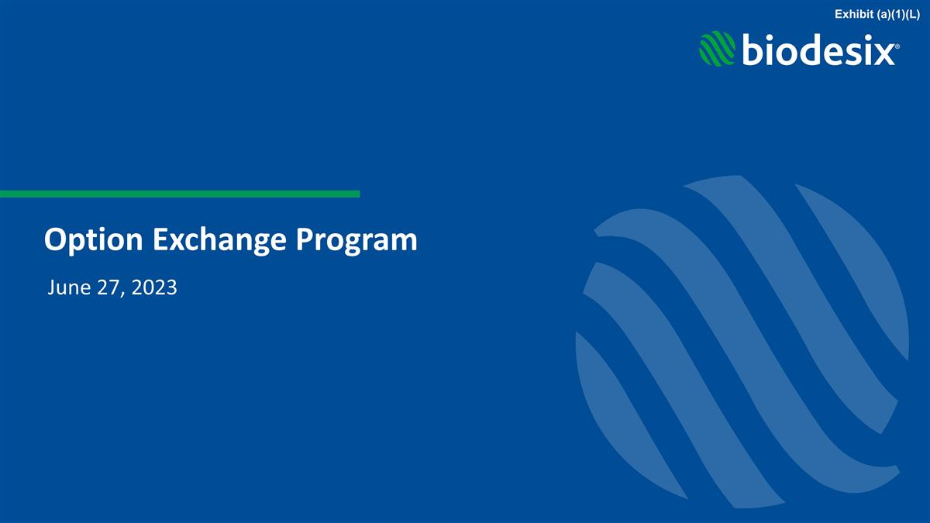
Option Exchange Program June 27, 2023 Exhibit (a)(1)(L)

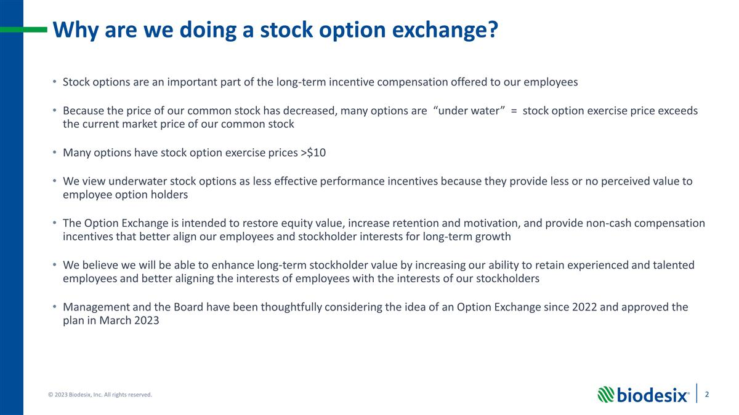
Why are we doing a stock option exchange? Stock options are an important part of the long-term incentive compensation offered to our employees Because the price of our common stock has decreased, many options are “under water” = stock option exercise price exceeds the current market price of our common stock Many options have stock option exercise prices >$10 We view underwater stock options as less effective performance incentives because they provide less or no perceived value to employee option holders The Option Exchange is intended to restore equity value, increase retention and motivation, and provide non-cash compensation incentives that better align our employees and stockholder interests for long-term growth We believe we will be able to enhance long-term stockholder value by increasing our ability to retain experienced and talented employees and better aligning the interests of employees with the interests of our stockholders Management and the Board have been thoughtfully considering the idea of an Option Exchange since 2022 and approved the plan in March 2023

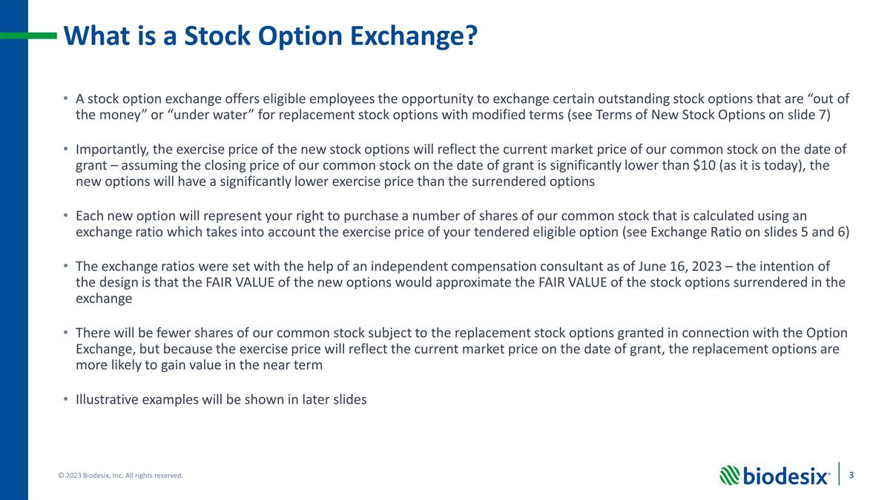
What is a Stock Option Exchange? A stock option exchange offers eligible employees the opportunity to exchange certain outstanding stock options that are “out of the money” or “under water” for replacement stock options with modified terms (see Terms of New Stock Options on slide 7) Importantly, the exercise price of the new stock options will reflect the current market price of our common stock on the date of grant – assuming the closing price of our common stock on the date of grant is significantly lower than $10 (as it is today), the new options will have a significantly lower exercise price than the surrendered options Each new option will represent your right to purchase a number of shares of our common stock that is calculated using an exchange ratio which takes into account the exercise price of your tendered eligible option (see Exchange Ratio on slides 5 and 6) The exchange ratios were set with the help of an independent compensation consultant as of June 16, 2023 – the intention of the design is that the FAIR VALUE of the new options would approximate the FAIR VALUE of the stock options surrendered in the exchange There will be fewer shares of our common stock subject to the replacement stock options granted in connection with the Option Exchange, but because the exercise price will reflect the current market price on the date of grant, the replacement options are more likely to gain value in the near term Illustrative examples will be shown in later slides

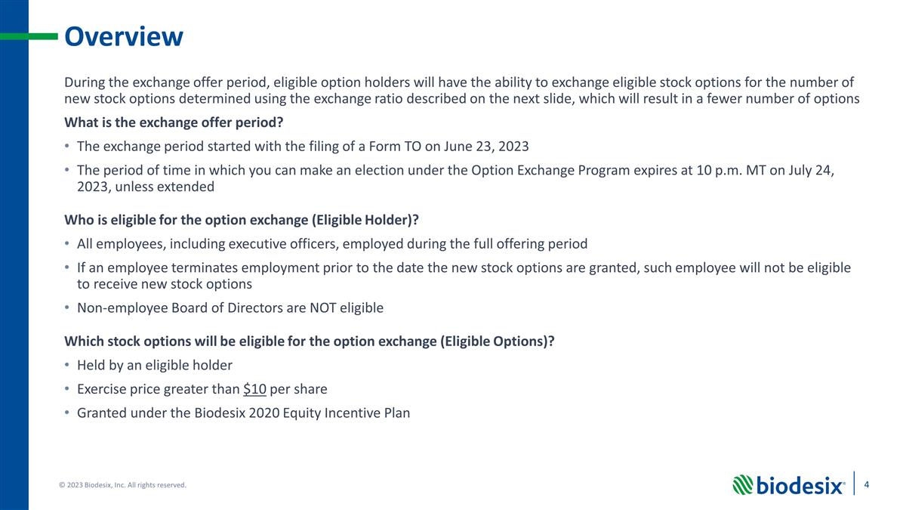
Overview During the exchange offer period, eligible option holders will have the ability to exchange eligible stock options for the number of new stock options determined using the exchange ratio described on the next slide, which will result in a fewer number of options What is the exchange offer period? The exchange period started with the filing of a Form TO on June 23, 2023 The period of time in which you can make an election under the Option Exchange Program expires at 10 p.m. MT on July 24, 2023, unless extended Who is eligible for the option exchange (Eligible Holder)? All employees, including executive officers, employed during the full offering period If an employee terminates employment prior to the date the new stock options are granted, such employee will not be eligible to receive new stock options Non-employee Board of Directors are NOT eligible Which stock options will be eligible for the option exchange (Eligible Options)? Held by an eligible holder Exercise price greater than $10 per share Granted under the Biodesix 2020 Equity Incentive Plan

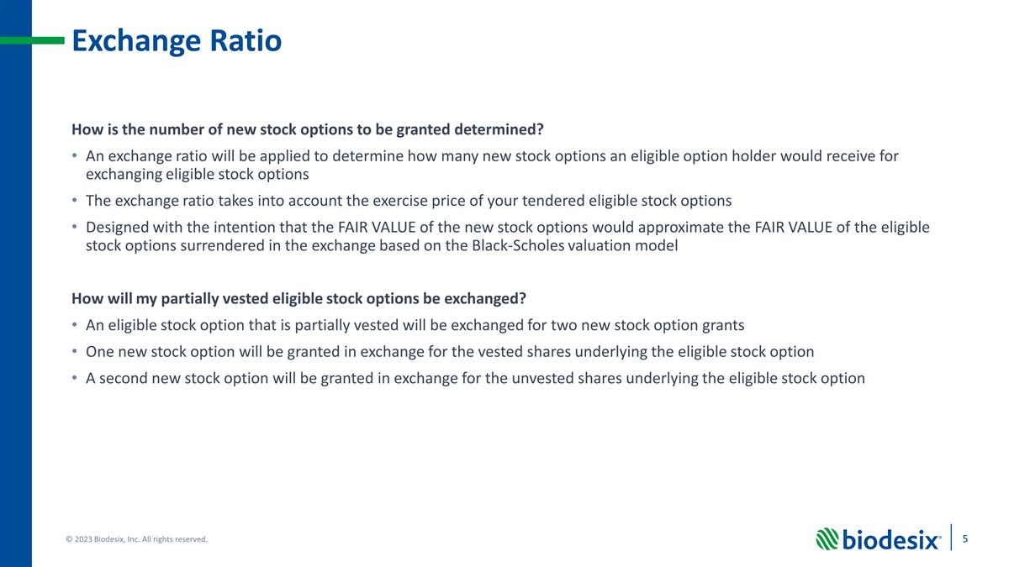
Exchange Ratio How is the number of new stock options to be granted determined? An exchange ratio will be applied to determine how many new stock options an eligible option holder would receive for exchanging eligible stock options The exchange ratio takes into account the exercise price of your tendered eligible stock options Designed with the intention that the FAIR VALUE of the new stock options would approximate the FAIR VALUE of the eligible stock options surrendered in the exchange based on the Black-Scholes valuation model How will my partially vested eligible stock options be exchanged? An eligible stock option that is partially vested will be exchanged for two new stock option grants One new stock option will be granted in exchange for the vested shares underlying the eligible stock option A second new stock option will be granted in exchange for the unvested shares underlying the eligible stock option

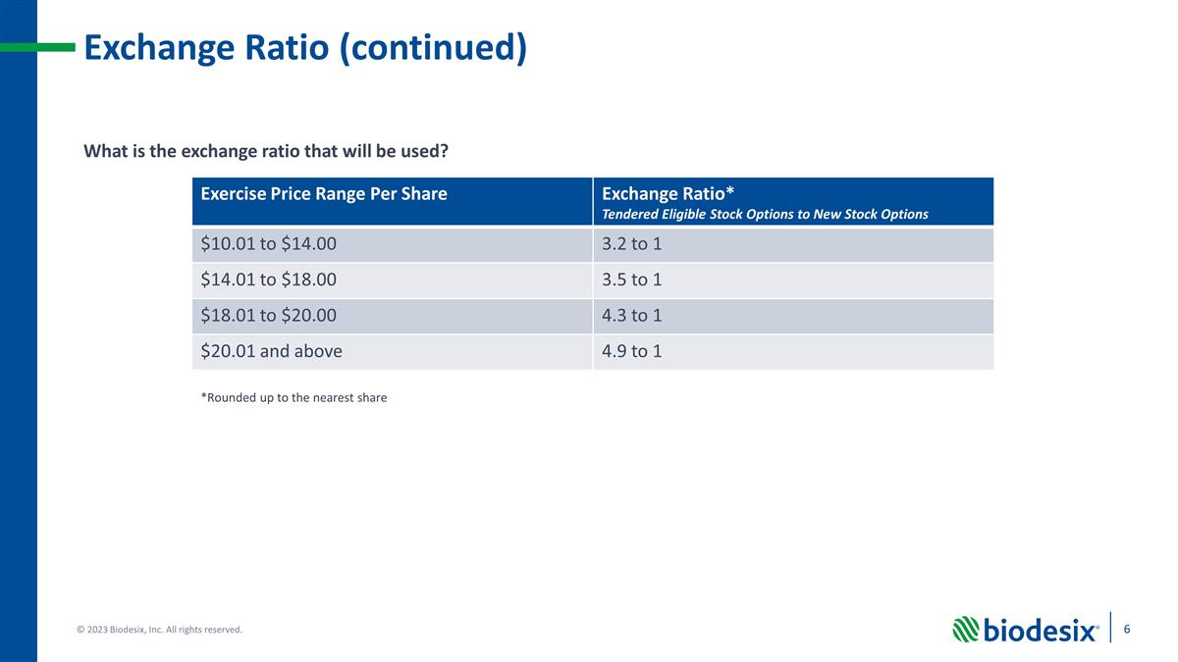
Exchange Ratio (continued) What is the exchange ratio that will be used? Exercise Price Range Per Share Exchange Ratio* Tendered Eligible Stock Options to New Stock Options $10.01 to $14.00 3.2 to 1 $14.01 to $18.00 3.5 to 1 $18.01 to $20.00 4.3 to 1 $20.01 and above 4.9 to 1 *Rounded up to the nearest share

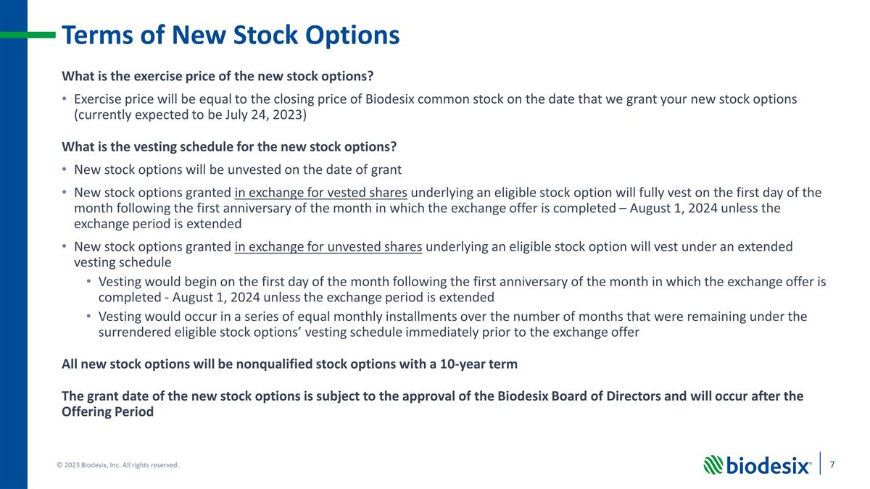
Terms of New Stock Options What is the exercise price of the new stock options? Exercise price will be equal to the closing price of Biodesix common stock on the date that we grant your new stock options (currently expected to be July 24, 2023) What is the vesting schedule for the new stock options? New stock options will be unvested on the date of grant New stock options granted in exchange for vested shares underlying an eligible stock option will fully vest on the first day of the month following the first anniversary of the month in which the exchange offer is completed – August 1, 2024 unless the exchange period is extended New stock options granted in exchange for unvested shares underlying an eligible stock option will vest under an extended vesting schedule Vesting would begin on the first day of the month following the first anniversary of the month in which the exchange offer is completed - August 1, 2024 unless the exchange period is extended Vesting would occur in a series of equal monthly installments over the number of months that were remaining under the surrendered eligible stock options’ vesting schedule immediately prior to the exchange offer All new stock options will be nonqualified stock options with a 10-year term The grant date of the new stock options is subject to the approval of the Biodesix Board of Directors and will occur after the Offering Period

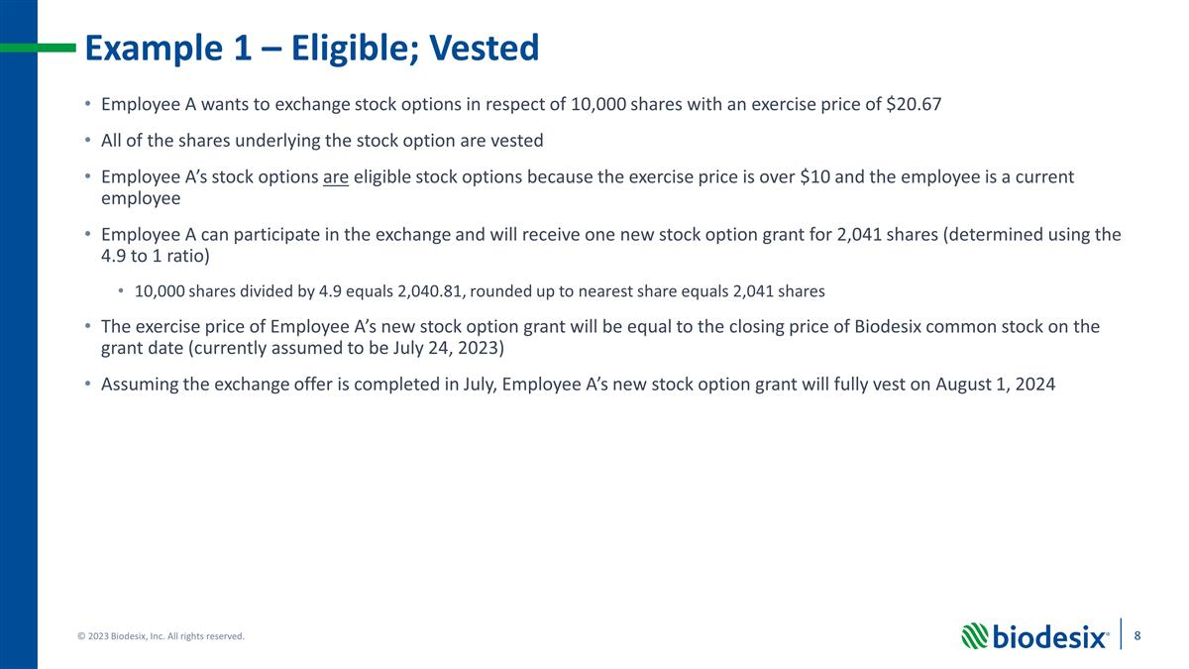
Example 1 – Eligible; Vested Employee A wants to exchange stock options in respect of 10,000 shares with an exercise price of $20.67 All of the shares underlying the stock option are vested Employee A’s stock options are eligible stock options because the exercise price is over $10 and the employee is a current employee Employee A can participate in the exchange and will receive one new stock option grant for 2,041 shares (determined using the 4.9 to 1 ratio) 10,000 shares divided by 4.9 equals 2,040.81, rounded up to nearest share equals 2,041 shares The exercise price of Employee A’s new stock option grant will be equal to the closing price of Biodesix common stock on the grant date (currently assumed to be July 24, 2023) Assuming the exchange offer is completed in July, Employee A’s new stock option grant will fully vest on August 1, 2024

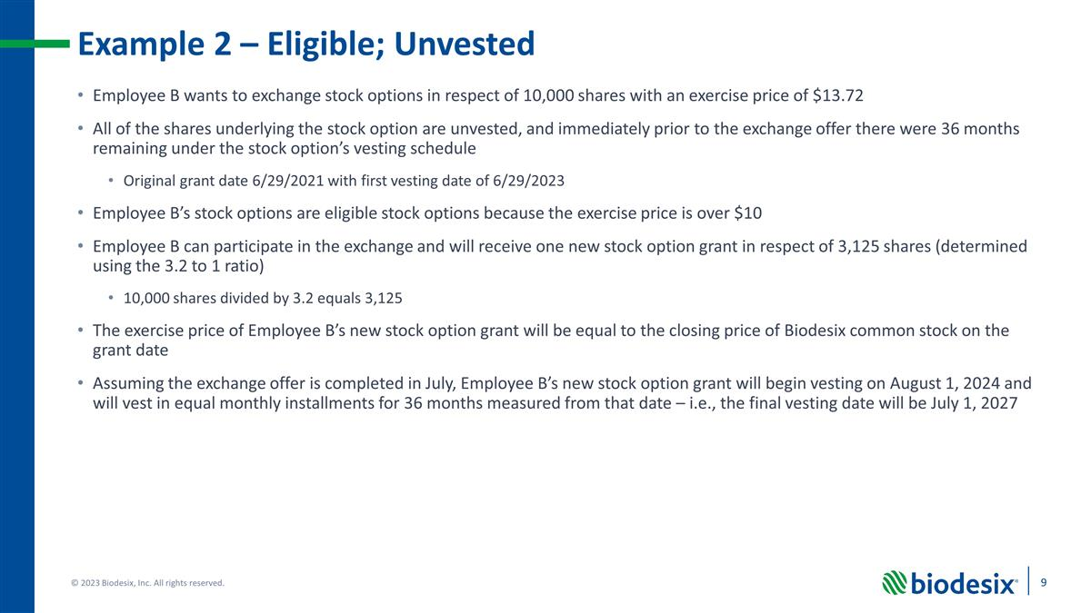
Example 2 – Eligible; Unvested Employee B wants to exchange stock options in respect of 10,000 shares with an exercise price of $13.72 All of the shares underlying the stock option are unvested, and immediately prior to the exchange offer there were 36 months remaining under the stock option’s vesting schedule Original grant date 6/29/2021 with first vesting date of 6/29/2023 Employee B’s stock options are eligible stock options because the exercise price is over $10 Employee B can participate in the exchange and will receive one new stock option grant in respect of 3,125 shares (determined using the 3.2 to 1 ratio) 10,000 shares divided by 3.2 equals 3,125 The exercise price of Employee B’s new stock option grant will be equal to the closing price of Biodesix common stock on the grant date Assuming the exchange offer is completed in July, Employee B’s new stock option grant will begin vesting on August 1, 2024 and will vest in equal monthly installments for 36 months measured from that date – i.e., the final vesting date will be July 1, 2027

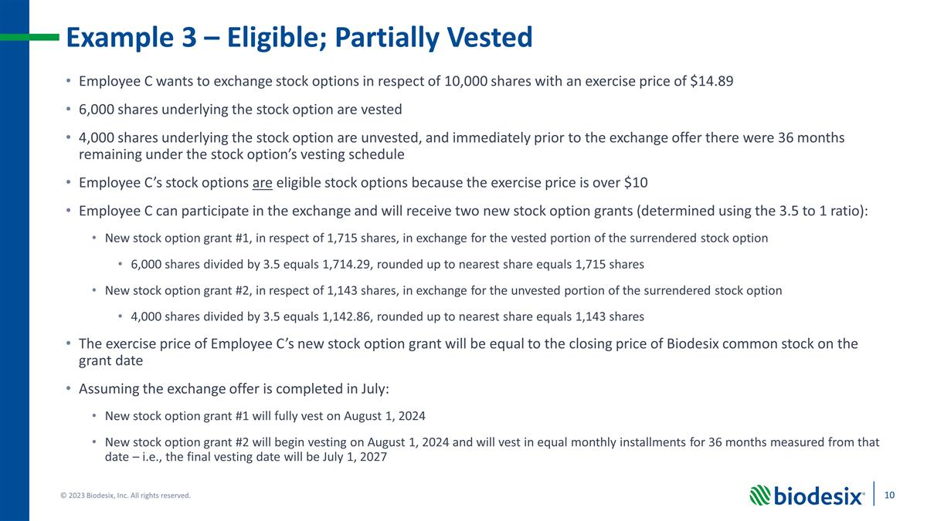
Example 3 – Eligible; Partially Vested Employee C wants to exchange stock options in respect of 10,000 shares with an exercise price of $14.89 6,000 shares underlying the stock option are vested 4,000 shares underlying the stock option are unvested, and immediately prior to the exchange offer there were 36 months remaining under the stock option’s vesting schedule Employee C’s stock options are eligible stock options because the exercise price is over $10 Employee C can participate in the exchange and will receive two new stock option grants (determined using the 3.5 to 1 ratio): New stock option grant #1, in respect of 1,715 shares, in exchange for the vested portion of the surrendered stock option 6,000 shares divided by 3.5 equals 1,714.29, rounded up to nearest share equals 1,715 shares New stock option grant #2, in respect of 1,143 shares, in exchange for the unvested portion of the surrendered stock option 4,000 shares divided by 3.5 equals 1,142.86, rounded up to nearest share equals 1,143 shares The exercise price of Employee C’s new stock option grant will be equal to the closing price of Biodesix common stock on the grant date Assuming the exchange offer is completed in July: New stock option grant #1 will fully vest on August 1, 2024 New stock option grant #2 will begin vesting on August 1, 2024 and will vest in equal monthly installments for 36 months measured from that date – i.e., the final vesting date will be July 1, 2027

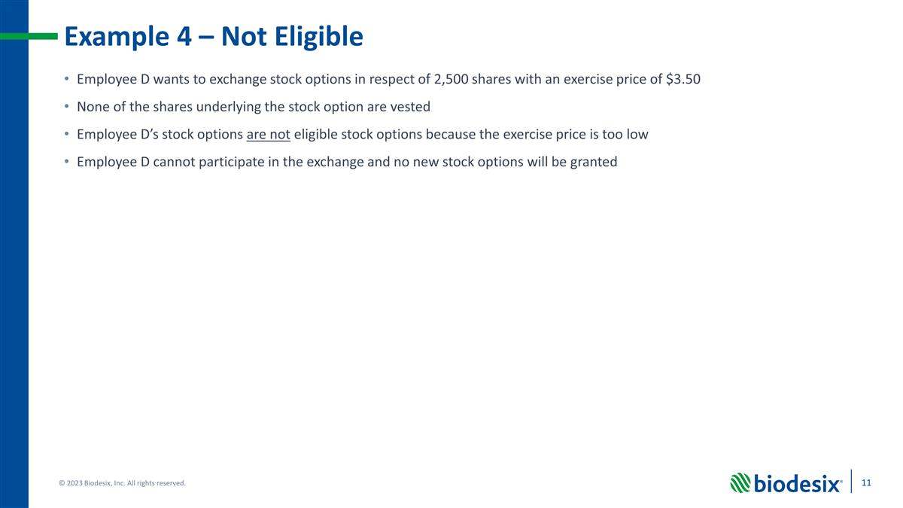
Example 4 – Not Eligible Employee D wants to exchange stock options in respect of 2,500 shares with an exercise price of $3.50 None of the shares underlying the stock option are vested Employee D’s stock options are not eligible stock options because the exercise price is too low Employee D cannot participate in the exchange and no new stock options will be granted

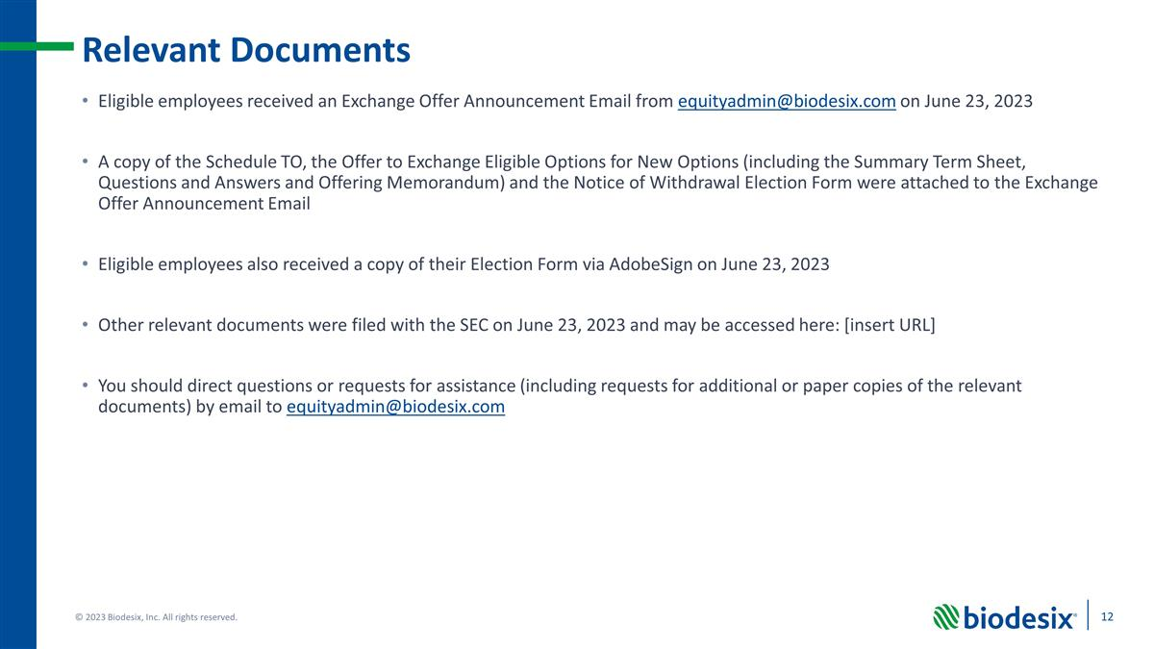
Relevant Documents Eligible employees received an Exchange Offer Announcement Email from equityadmin@biodesix.com on June 23, 2023 A copy of the Schedule TO, the Offer to Exchange Eligible Options for New Options (including the Summary Term Sheet, Questions and Answers and Offering Memorandum) and the Notice of Withdrawal Election Form were attached to the Exchange Offer Announcement Email Eligible employees also received a copy of their Election Form via AdobeSign on June 23, 2023 Other relevant documents were filed with the SEC on June 23, 2023 and may be accessed here: [insert URL] You should direct questions or requests for assistance (including requests for additional or paper copies of the relevant documents) by email to equityadmin@biodesix.com

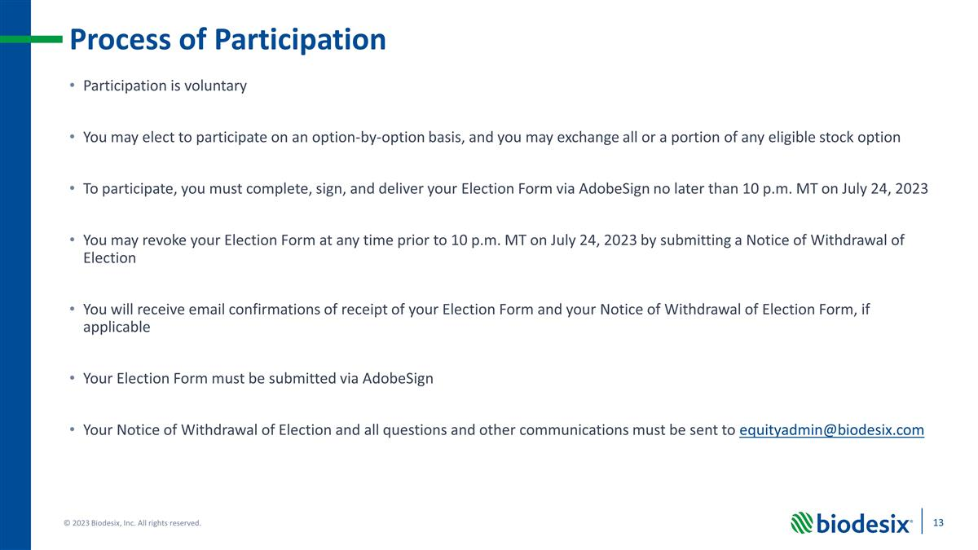
Process of Participation Participation is voluntary You may elect to participate on an option-by-option basis, and you may exchange all or a portion of any eligible stock option To participate, you must complete, sign, and deliver your Election Form via AdobeSign no later than 10 p.m. MT on July 24, 2023 You may revoke your Election Form at any time prior to 10 p.m. MT on July 24, 2023 by submitting a Notice of Withdrawal of Election You will receive email confirmations of receipt of your Election Form and your Notice of Withdrawal of Election Form, if applicable Your Election Form must be submitted via AdobeSign Your Notice of Withdrawal of Election and all questions and other communications must be sent to equityadmin@biodesix.com

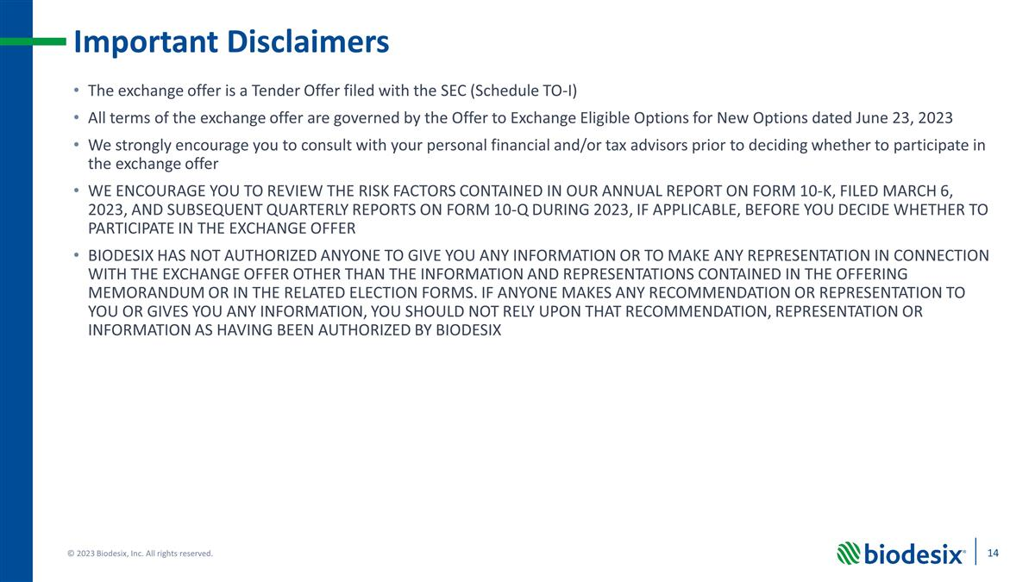
Important Disclaimers The exchange offer is a Tender Offer filed with the SEC (Schedule TO-I) All terms of the exchange offer are governed by the Offer to Exchange Eligible Options for New Options dated June 23, 2023 We strongly encourage you to consult with your personal financial and/or tax advisors prior to deciding whether to participate in the exchange offer WE ENCOURAGE YOU TO REVIEW THE RISK FACTORS CONTAINED IN OUR ANNUAL REPORT ON FORM 10-K, FILED MARCH 6, 2023, AND SUBSEQUENT QUARTERLY REPORTS ON FORM 10-Q DURING 2023, IF APPLICABLE, BEFORE YOU DECIDE WHETHER TO PARTICIPATE IN THE EXCHANGE OFFER BIODESIX HAS NOT AUTHORIZED ANYONE TO GIVE YOU ANY INFORMATION OR TO MAKE ANY REPRESENTATION IN CONNECTION WITH THE EXCHANGE OFFER OTHER THAN THE INFORMATION AND REPRESENTATIONS CONTAINED IN THE OFFERING MEMORANDUM OR IN THE RELATED ELECTION FORMS. IF ANYONE MAKES ANY RECOMMENDATION OR REPRESENTATION TO YOU OR GIVES YOU ANY INFORMATION, YOU SHOULD NOT RELY UPON THAT RECOMMENDATION, REPRESENTATION OR INFORMATION AS HAVING BEEN AUTHORIZED BY BIODESIX

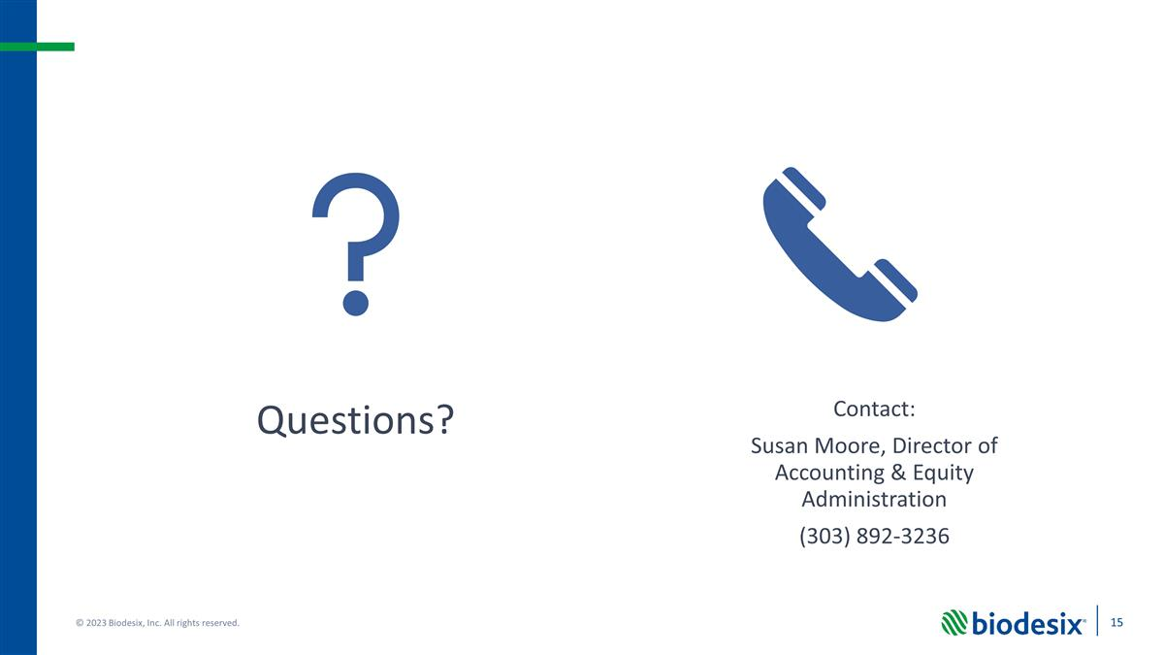
Exhibit 107
EX-FILING FEES
Calculation of Filing Fee Tables
Schedule TO
(Form Type)
Biodesix, Inc.
(Exact Name of Registrant as Specified in its Charter)
Table 1 to Paragraph [(a)(7)]

 |  | Transaction  Valuation |  | Fee  rate |  | Amount of  Filing Fee**
Fees to Be Paid |  | $1,131,626.80* |  | .011020% |  | $124.71
Fees Previously Paid |  | $ 0.00* |  |  |  | $ 0
Total Transaction Valuation |  | $ 124.71*
Total Fees Due for Filing |  |  |  |  |  | $124.71
Total Fees Previously Paid |  |  |  |  |  | $ 0
Total Fee Offsets |  |  |  |  |  | $ 0
Net Fee Due |  |  |  |  |  | $124.71

* | Estimated solely for purposes of calculating the amount of the filing fee pursuant to Rule 0-11 of the Securities Exchange Act of 1934, as amended (the Exchange Act), based on the product of (i) $1.39, the average of the high and low prices per share of the Issuers Common Stock on June 20, 2023 as reported on the Nasdaq Global Select Market and (ii) 814,120, the estimated number of shares of Common Stock to be exchanged in the transaction.
** | The filing fee was calculated in accordance with Rule 0-11 under the Exchange Act and the Fee Rate Advisory #1 for Fiscal Year 2023, issued August 26, 2022, by multiplying the transaction value by 0.00011020.

