UNITED STATES
SECURITIES AND EXCHANGE COMMISSION
Washington, DC 20549

SCHEDULE 14A
(Rule 14a-101)
SCHEDULE 14A INFORMATION
Proxy Statement Pursuant to Section 14(a) of the Securities Exchange Act of 1934
(Amendment No. )

☒ |  | Filed by the Registrant
☐ |  | Filed by a Party other than the Registrant
Check the appropriate box:
☐ |  | Preliminary Proxy Statement
☐ |  | Confidential, for Use of the Commission Only (as permitted by Rule 14a-6(e)(2))
☐ |  | Definitive Proxy Statement
☒ |  | Definitive Additional Materials
☐ |  | Soliciting Material under § 240.14a-12
Biodesix, Inc.

(Name of Registrant as Specified in its Charter)

(Name of Person(s) Filing Proxy Statement, if Other Than the Registrant)
Payment of Filing Fee (Check the appropriate box):

☒ |  | No fee required.
☐ |  | Fee paid previously with preliminary materials.
☐ |  | Fee computed on table in exhibit required by Item 25(b) per Exchange Act Rules 14a-6(i)(1) and 0-11.

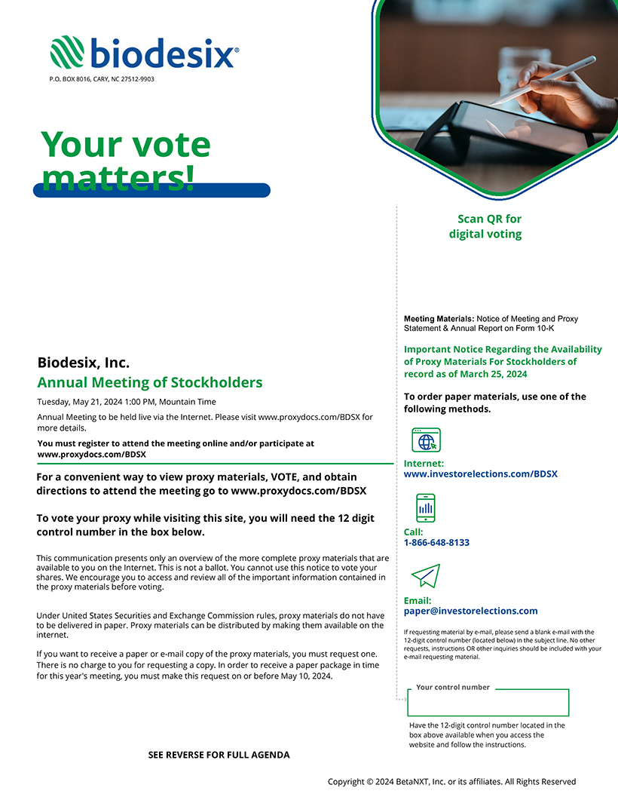
biodesix P.O. BOX 8016, CARY, NC 27512-9903 Your vote matters! Biodesix, Inc. Annual Meeting of Stockholders Tuesday, May 21, 2024 1:00 PM, Mountain Time Annual Meeting to be held live via the Internet. Please visit www.proxydocs.com/BDSX for more details. You must register to attend the meeting online and/or participate at www.proxydocs.com/BDSX For a convenient way to view proxy materials, VOTE, and obtain directions to attend the meeting go to www.proxydocs.com/BDSX To vote your proxy while visiting this site, you will need the 12 digit control number in the box below. This communication presents only an overview of the more complete proxy materials that are available to you on the Internet. This is not a ballot. You cannot use this notice to vote your shares. We encourage you to access and review all of the important information contained in the proxy materials before voting. Under United States Securities and Exchange Commission rules, proxy materials do not have to be delivered in paper. Proxy materials can be distributed by making them available on the internet. If you want to receive a paper or e-mail copy of the proxy materials, you must request one. There is no charge to you for requesting a copy. In order to receive a paper package in time for this years meeting, you must make this request on or before May 10, 2024. Scan QR for digital voting Meeting Materials: Notice of Meeting and Proxy Statement & Annual Report on Form 10-K Important Notice Regarding the Availability of Proxy Materials For Stockholders of record as of March 25, 2024 To order paper materials, use one of the following methods. Internet: www.investorelections.com/BDSX Call: 1-866-648-8133 Email: paper@investorelections.com If requesting material by e-mail, please send a blank e-mail with the 12-digit control number (located below) in the subject line. No other requests, instructions OR other inquiries should be included with your e-mail requesting material. Your control number Have the 12-digit control number located in the box above available when you access the website and follow the instructions. SEE REVERSE FOR FULL AGENDA Copyright © 2024 BetaNXT, Inc. or its affiliates. All Rights Reserved

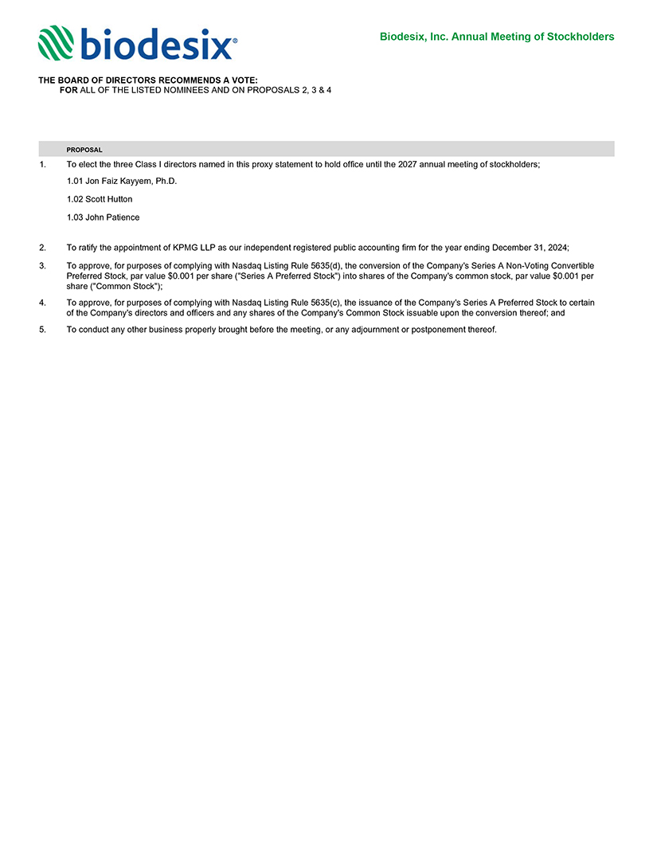
biodesix Biodesix, Inc. Annual Meeting of Stockholders THE BOARD OF DIRECTORS RECOMMENDS A VOTE: FOR ALL OF THE LISTED NOMINEES AND ON PROPOSALS 2, 3 & 4 PROPOSAL 1. To elect the three Class I directors named in this proxy statement to hold office until the 2027 annual meeting of stockholders; 1.01 Jon Faiz Kayyem, Ph.D. 1.02 Scott Hutton 1.03 John Patience 2. To ratify the appointment of KPMG LLP as our independent registered public accounting firm for the year ending December 31, 2024; 3. To approve, for purposes of complying with Nasdaq Listing Rule 5635(d), the conversion of the Companys Series A Non-Voting Convertible Preferred Stock, par value $0.001 per share (Series A Preferred Stock) into shares of the Companys common stock, par value $0.001 per share (Common Stock); 4. To approve, for purposes of complying with Nasdaq Listing Rule 5635(c), the issuance of the Companys Series A Preferred Stock to certain of the Companys directors and officers and any shares of the Companys Common Stock issuable upon the conversion thereof; and 5. To conduct any other business properly brought before the meeting, or any adjournment or postponement thereof.

